In Nursery, our topic this half term is, ‘Once Upon a Time’. This means that much of our work will be centred around traditional tales. Here are some examples of activities that we would like your child to take part in. You should aim to complete and send in evidence of at least three of these activities. We will display them in our classrooms. You can bring them in as soon as they have been completed. The final date for completion is 14th October 2022. ​
Think about your favourite story and try to retell this to your Mummy/ Daddy as a bedtime story.
Visit the library and select a range of Traditional Tales to read and share at home.

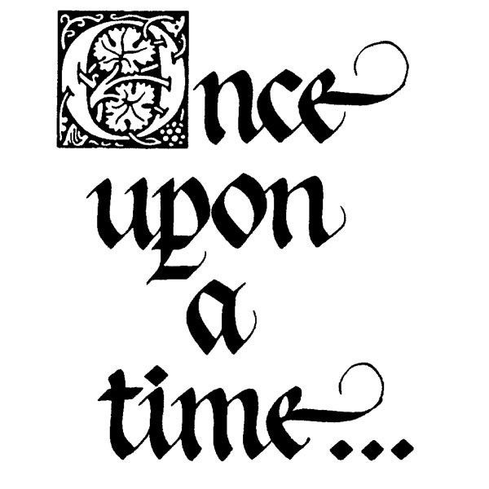
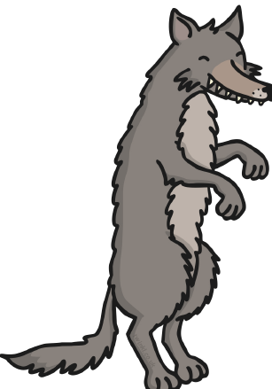
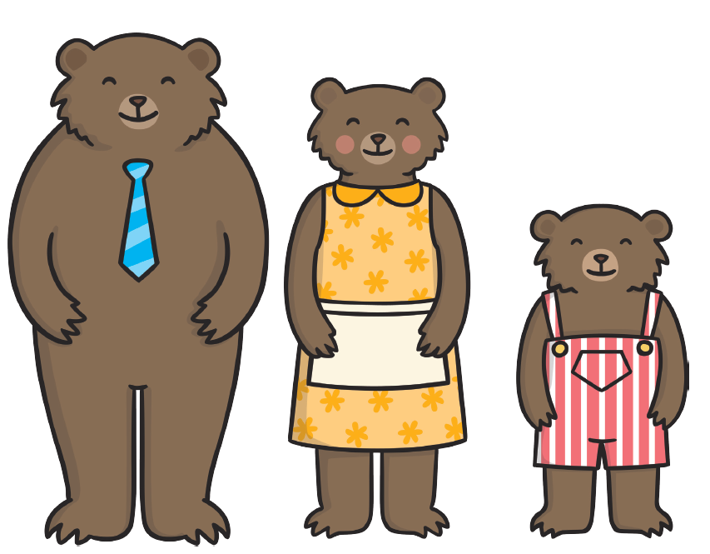
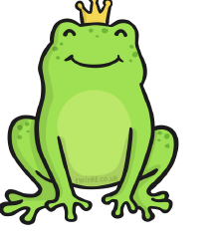
Can you recognise your name? Can you write some of the letters in your name?

Count out magic beans/ coins. Focus on counting accurately when the beans/ coins are in a straight line.
Make puppets from a Traditional Tale and hold a puppet show.
Taste some porridge and try and add some yummy toppings to it- what did you think?
Measure different plants to find out which is the tallest/ shortest.
Have a look in the mirror and practice what you might look like when displaying different emotions.

Make/ decorate a Gingerbread man- yummy
Act out your favourite traditional tale and take photos of your performance.

