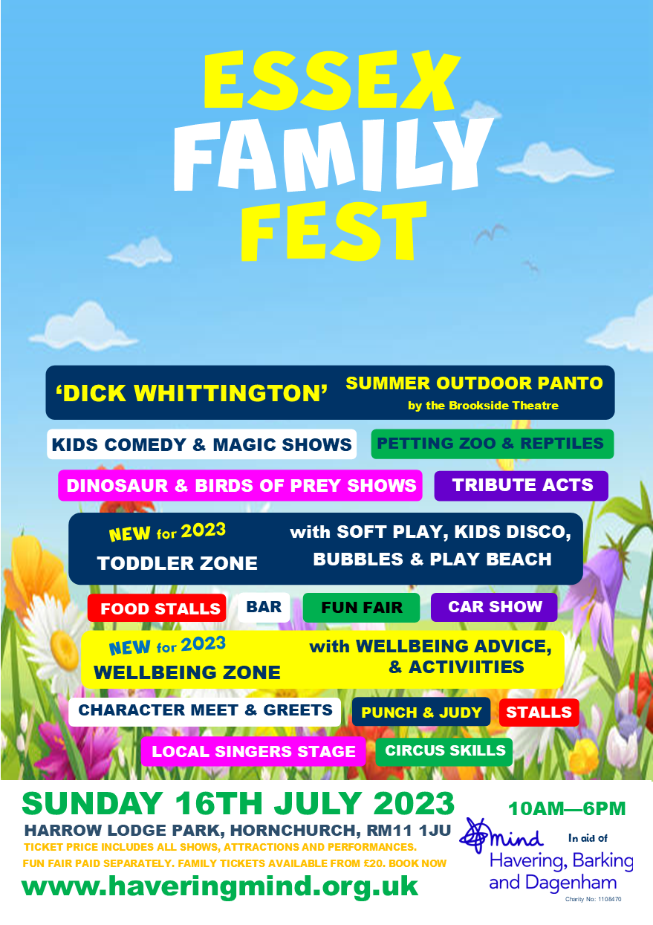

Essex Family Fest is back on Sunday 16th July 2023 in Harrow Lodge Park, Hornchurch, RM11 1JU
Come along between 10am – 6pm and enjoy a fantastic family day out.
New for 2023

‘Toddler Zone’ with soft play, play beach and bubble shows
‘Wellbeing Zone’ with practical advice, activities and information
‘Dick Whittington’ outdoor panto performed by the Brookside Theatre Company
Don’t miss
· Kids Magic and Comedy Shows
· Tribute Acts
· Dinosaurs
· Bird of Prey
· Petting Zoo and Reptiles
There will also be a Funfair, Car Show, Bar and Food Stalls and much, much more!
It’s a fun filled few hours, brought to you by local mental health charity Mind in Havering, Barking & Dagenham

Advance tickets can be purchased from the website below:

https://www.haveringmind.org.uk/event/essex-family-fest-2/

Please enter the code BRADY10 at checkout and Havering Mind will donate 10% of all tickets purchased by Brady Primary school Parents/Carers etc to the school’s PTA.

