Mysterious Island
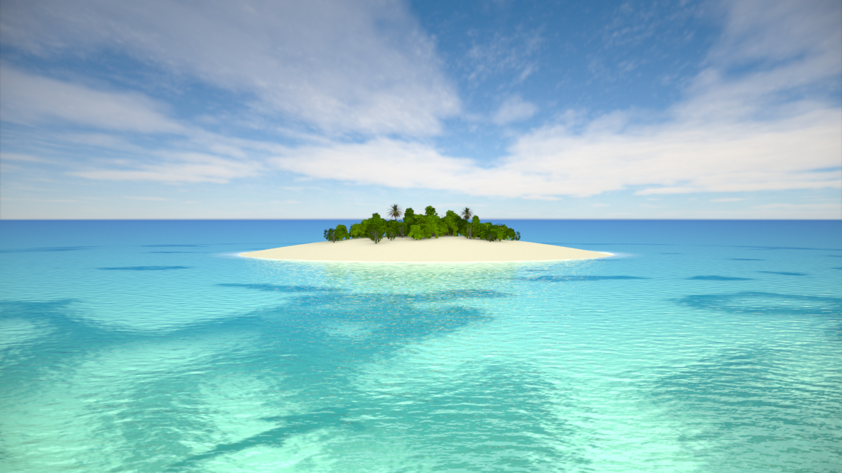

Elongated peanut, squashed and stretched,
Floating upon the shimmering blue sea,
Surrounded by a white frame,
It was an emerald green jewel,
Sitting in the middle of the big, blue sea.

Small and mysterious,
Like a grain of rice,
Three to two miles long,
Nobody would know it was there,
Hidden in the lonely sapphire sea.

Big, grey rocks sitting on the white sand,
Howling through the trees,
Emerald green trees sitting on brown trunks,
Standing scared,
With only the sound of the sapphire sea.

The howling of the gibbons,
The tweeting of birds,
Whistling trees,
Waves crashing,
Alone…

By Megan

