History

* Speak to older members of your family to find out how their childhoods were similar to or different from yours. Ask them about a range of topics, such as toys, food, home and school. Draw pictures or write some sentences to record what they say.
* Make a family tree. Write a list of the people in your family. How many people are there? Can you remember all their names? How are they related to you?
* Think of a special event from your family’s history. It could be a birthday or another special celebration. Draw a picture to show what happened and write a sentence about it.
* Here are some pictures of toys that were popular in the past. Name each toy and write a sentence to say how these toys are different from the toys that you play with.

These activities are for you to do at home with an adult. You can do all of them or choose the ones that you find most interesting.

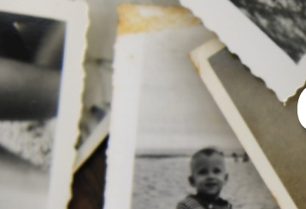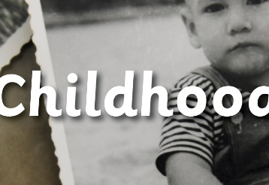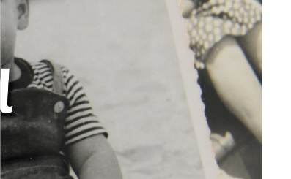

Maths

* Login to Numbots
* Take pictures of 3D and 2D shapes you can find around your home.
* Count forwards and backwards from 20.

English

* Ask someone in your family what you were like as a baby and look at your baby photographs. Make a list of things that can you do now that you couldn’t do then.
* Write some sentences about what you have learned about childhood today and in the past.

Science

* Organise the stages of human life into the correct order on a timeline.

* Use magazines, books and family photographs to find out how humans change as they grow. Look for people at different stages of life, including baby, toddler, child, teenager, adult and elderly. Draw a picture and write a sentence about each stage of human life.



Art & DT

* Make an information poster about your family. Share your poster with someone in your family for feedback.
* Draw a family portrait.

