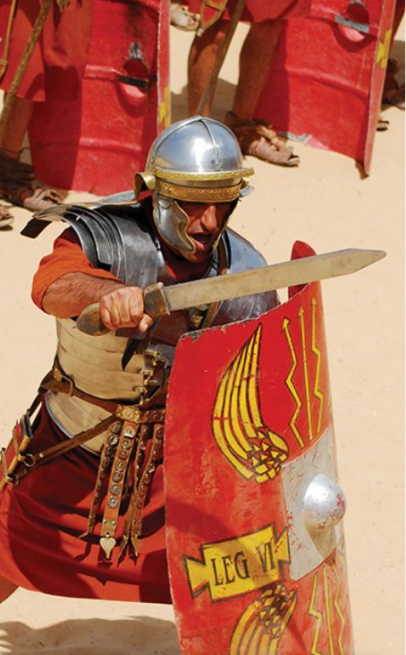

**PE**

* This term, PE will be on a **Tuesday morning.** Please ensure that children come into school wearing their PE kit.

**Maths**

Throughout this term, we will be:

* Revising place value, with numbers up to 10,000 and comparing up to 5-digit numbers
* Learning Roman Numerals up to 100
* Partitioning numbers, as well as rounding to the nearest 10, 100 and 1,000
* Estimating and finding 1, 10, 100, 1,000 more or less of a number
* Adding and subtracting up to two 4-digit numbers
* Continuing to practice times tables, including our weekly times table test

**Literacy**

* This term, we are reading the book called The Firework-Maker’s Daughter. We will be focussing on improving our skills in vocabulary, inference, predictions, retrieval and summarising.
* We will also be writing a character description of Boudicca, who we are studying across a number of lessons. To do this, we will be looking at key features to include in this piece of writing. Later in the term, we will also be working on writing instructions, and improving our grammar knowledge.

**Topic**

* In History/Geography, we will be learning about Boudicca and the Roman Empire, and the Roman invasion of Britain. We will also be comparing the human and physical features of Italy and England.
* In Art we are studying portraits, and the children will be creating their own portrait of Boudicca.
* In Science, we will be learning about States of Matter, comparing the forms of solids, liquids and gases.
* In Computing, we will be studying what it means to programme, and creating our own educational games.
* We will also be continuing to study RE and French, as well as having time dedicated to handwriting and spelling.

I am Warrior!