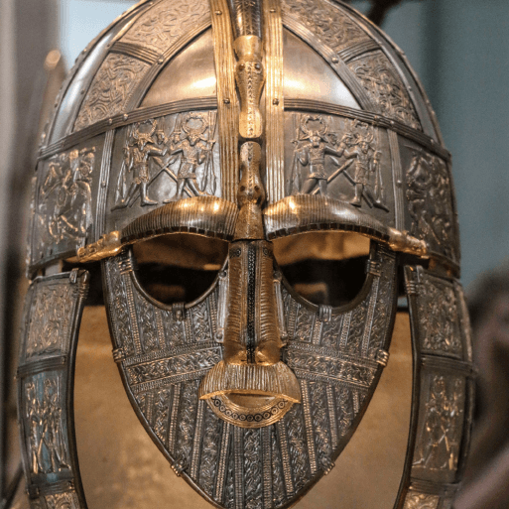

Invasion

**Maths**

* Keep practicing your multiplication and division facts for each times-table (up to 12s).
* Measure the area of some items found around the house- your dining table, a box of cereal, a place mat etc…

**Geography/History**

* Use a range of historical source materials to research what everyday life was like in Anglo-Saxon or Viking Britain. Areas to research might include clothing, housing, food, culture or religion. Create a non-chronological report, blog or presentation to present your findings.
* Research a significant Anglo-Saxon or Viking figure and create a fact file or biography about your chosen individual. Examples: Alfred the Great, King Offa, Lady Aethelflaed, Bede, Ivar the Boneless, Guthrum, Sweyn Forkbeard and Cnut the Great.
* Use a range of resources to create a knowledge organiser about the Battle of Hastings. Include details about key dates, people and events and a paragraph to explain why this battle was so significant for England.

**Art and Design**

* Use the internet to search for pictures of the artefacts found at the Sutton Hoo burial site, such as The Franks casket, purse lid and shoulder clasp. Create a piece of Anglo-Saxon art using the designs on the artefacts as inspiration.

**Literacy**

* Imagine you are an Anglo-Saxon invader. Write a letter home to your family in Denmark, The Netherlands or Germany. Include details about the journey to England, where you have settled and explain any difficulties you have faced.
* Imagine you are a monk at Lindisfarne, who witnessed the Viking attacks on the monastery. Write a soliloquy explaining what you saw and include your thoughts and feelings about the attack.
* Examples of books to read: 