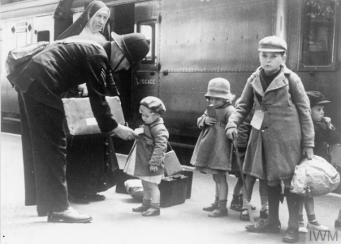

**Art**

* In Art this term we will be looking at how to create different tints, tones and shades.
* We will be using this information to create our own landscape painting.

**Maths**

When learning about measures we will be:

* Converting and calculating metric measures
* Converting between miles and kilometres
* Identifying and converting imperial measures

When learning about perimeter, area and volume we will be:

* Identifying shapes that have the same area
* Calculating the area of a triangle / parallelogram
* Calculating the volume of cuboids

When learning about ratio we will be:

* Using ratio and fractions
* Calculating ratio
* Using scale factors

**History**

In History this term, we will be continuing our work on Britain during World War Two. We will be looking into significant events such as the battle of Britain and significant individuals such as Anne Frank. We will also be looking at post war Britain and how we remember these important events today.

**English**

* This term in English we will be writing narratives. We will be using a variety of stimuli for our writing and will be looking at how we can engage our reader using description.
* In Reading, we will be looking at poem “The Lady of Shalott” and we will be using this poem to complete a range of activities. We will be answering our VIPERS questions based on this text

**Science**

* For Science this term we will be learning about blood. We will be learning about the composition of blood and how it travels through our body.
* We will look at how a healthy / unhealthy lifestyle can impact our heart health

**Britain at War (2)**