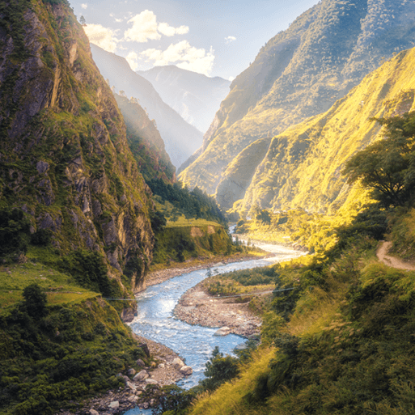

**Topic**

* In Geography, we will be learning about various rivers and mountains from around the world, as well as features of both of them. This will also span into our Computing lessons, in which the children will conduct their own research.
* In Art, we are looking at the history of animals in art, and using that knowledge to create our own clay sculptures.
* In Science, we will be learning about Living Things and their Habitats, focussing on Animals and the different environments they live in.
* In Music, we will be learning different keys/songs on our glockenspiels.
* For our RE lessons, the children will be learning about key figures who inspire us.
* The children will continue to learn French weekly, focussing on recapping basic conversational phrases, and then moving onto the topic of Food.

**PE**

* This term, the children will be going **swimming on a Tuesday morning**. Please ensure that the children bring everything that they need with them each Tuesday, including: wearing their PE kit, a towel, swimming costume/trunks and a swimming cap. Please refer to the letter for more information.

**Maths**

Throughout this term, we will be:

* Comparing and converting lengths such as mm, cm, m and km.
* Measuring perimeter.
* Adding and subtracting lengths.
* Working on division facts.
* Continuing to practice our specific times tables for the weekly test (still on Tuesday mornings).

**Literacy**

* This term, we are reading the novel The Lion, the Witch and the Wardrobe by C.S. Lewis. We will be continuing to develop our skills in defining vocabulary, inference, making predictions, retrieval and summarising/sequencing events.
* In writing, we will begin by producing a Setting Description of an area similar to the image displayed on the left hand-side of this newsletter. Later in the term, the children will produce a Fact File on a river/mountain of their choice. We will also continue to work on our spelling, grammar and punctuation skills.

Misty Mountain,

Winding River.