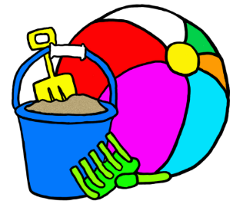
Reception Newsletter- Summer 2

Hello and welcome back, we hope you had a lovely half term break. We can’t believe we are almost at the end of our year together. We are looking forward to a lovely half term.
This half term, we have two mini projects – “Marvellous Machines” and then “Moving On”.
In Marvellous Machines, we will be learning about vehicles, how machines work, comparing machines from the past and now, playing with machine toys and designing our own robots.
In Moving On, we will be going up the school to look at our new Year 1 classrooms! We will be talking about the changes ahead and reading some amazing stories, like Knuffle Bunny, Knuffle Bunny Too and Knuffle Bunny Free.
In maths, we will be learning about odds, evens, doubling and sharing. We will be making maps, using positional language and solving practical problems. We will even be designing mazes!
In phonics, the children will be re-assessed and will continue their phonics learning in small groups. Some children will have new teachers, this will be explained to you once the results are recorded.
Please ensure that you hear your child read their reading book at least 3 times a week. Please ensure your child always has their reading record and book in their bookbags every day, as some children’s reading books are used more than once a week.
Please be mindful of the weather. Children should bring a hat to school in hot weather, as well as their water bottle. They should also have sun cream applied before the start of the school day. We cannot reapply sun cream in school hours.
We can’t believe the Reception year is almost finished, and are looking forward to making lasting memories with your children and learning lots before they continue their adventure here at Brady up in to Year 1.
Sports Day will be on Monday 27th June 2022. For Reception and KS1 this will be between 9:30am- 11:30am.
We will be taking a trip to Rainham Library this Half Term- more details to follow soon.
Please provide your child with a plain polo top for an art activity we are making this half term.
Kind Regards,
Mrs Divall, Mrs Zaayman and Mrs Degun

