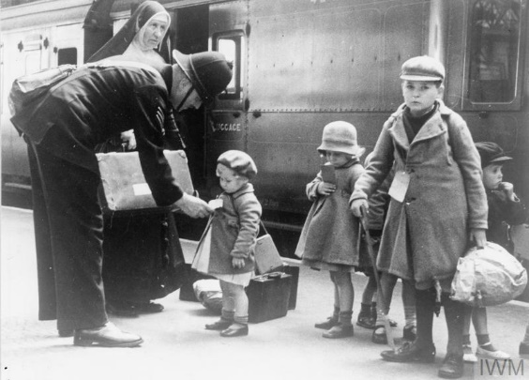

**Science**

* For Science this term we will be learning about light. As part of this topic we will be learning about how light travels in order for us to see.
* We will look at how we can reflect and refract light and will identify the colours of the light spectrum.

**RE/ Art**

* In Re we will be looking at respect and how different religions show respect
* We will also be looking at ways to make out own town a respectful place.
* When learning about Islam we will look at the five pillars and why prayer is important to Muslims.
* Distortion and abstraction within art and how to create our own version of this.

**Maths**

This term we will be looking at ratio, algebra and decimals. We will be learning and revising how to:

* Comparing ratio and proportion
* Using ratio to find different amounts in recipes
* The difference between an expression and an equation
* Forming and solving equations
* Read and use decimals with up to three decimal places.
* Multiply and divide by 10, 100 and 1000
* Multiply and divide decimals by integers

**History**

In History we will be looking at Britain during WW1 and WW2. For World War 1 we will be learning how these conflicts started, looking at life in the trenches and identifying key events. When learning about World War 2, we will be identifying key events, researching the weapons and technology used and looking at how the war impacted the lives of British civilians.

**English**

* For English this term we will be starting our writing by describing a setting. We will be using the text “Journey” to base our writing on.
* We will also be looking at diary entries and revising our use of past tense. We will also be learning how to use hyphens in our work to avoid ambiguity.
* We will also be writing a balanced argument using information and ideas from our class text.
* Our class text this term will be ‘Friend or Foe’, we will be using this text to complete a range of activities and will be answering our VIPERS questions based on this text

**Britain at War**