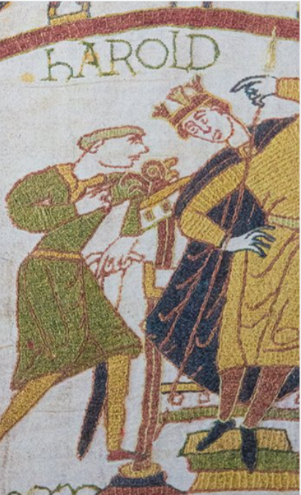

**PE**

* This term, the children will be going **swimming on a Friday morning**. Please ensure that the children bring everything that they need with them each Friday, including: wearing their PE kit, a towel, swimming costume/trunks and a swimming cap. Please refer to the letter for more information.

**Maths**

Throughout this term, we will be:

* Comparing and converting lengths such as mm, cm, m and km.
* Measuring perimeter.
* Adding and subtracting lengths.
* Working on division facts.
* Continuing to practice our specific times tables for the weekly test (now on a Friday morning)

**Literacy**

* This term, we are reading the novel The Lion, the Witch and the Wardrobe by C.S. Lewis. We will be continuing to develop our skills in defining vocabulary, inference, making predictions, retrieval and summarising/sequencing events.
* In writing, we will begin by producing a Setting Description of a magical kingdom, based on the book ‘The Journey’. Later in the term, the children will produce a Fact File on an area that they will undertake research on; this may be a famous river, a significant historical figure or a country.

**Topic**

* Due to our topic being 1066, in History/Geography we will be looking into the Battle of Hastings in detail, including the events in the lead up to the battle and the effect that the Norman Invasion had on Britain.
* For our RE lessons, the children will be learning about key figures who inspire us. This will include religious and non-religious figures.
* In Science, our topic will be ‘Sound’. We will be learning all about the different parts of the ear, how sound is made and why it sounds different depending on the material/instrument used.
* During our DT module, we will be studying fabrics. We will be looking at different types of fabric and material and then practising our sewing skills by sewing a hem.
* We will also continue to have weekly Music, Computing, PSHE and French lessons, continuing on with the learning we began in Autumn term.

1066