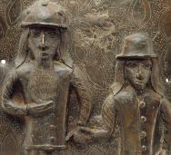

**Maths**

When learning about Shape, we will be covering:

* How to measure angles accurately
* Calculating missing angles within different shapes
* The different properties of circles
* Drawing shapes accurately
* Nets of 3D shapes

When learning about position and direction, we will be covering:

* Reading and plotting coordinates
* Translations
* Reflections

**Science**

* For Science this term we will be learning about evolution and inheritance. We will be learning about inherited traits and apply this knowledge to various animals and plants, before being introduced to the work of Mary Anning and Charles Darwin.

**English**

* This term in English we will be writing a persuasive letter and a non-chronological report. We will be developing key skills by including language fitting for each genre to show formality.

**Maafa**

**History**

In history this half term we will be looking at Africa past and present, with a particular focus on Benin. We will be learning about the slave trade and explore Britain’s role in the transatlantic slave trade and the causes and consequences of the European colonisation of Africa.