­­



Tell us something that your child has done that has put a sunny smile on your face…

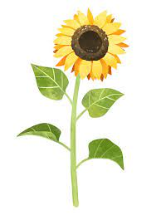











What was your child’s favourite learning last half term? Please refer to our lovely school website to jog their memories!

Does your child have any questions they would like answered in our new topic, Sunshine and Sunflowers?

Please return your sunny smiles by Friday 24th February 2023. 😊