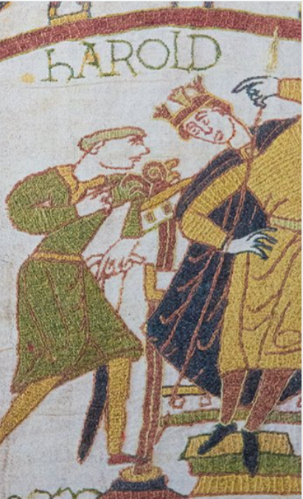

**Various**

* Use information books and online sources to help you answer the enquiry question ‘Who were the Normans and what was the Norman Conquest of England?’ Write a few paragraphs to answer the question.
* Find out about the historical figures listed and their importance to the story of the Norman Conquest of England. Write a paragraph about each figure. Include details about when each figure lived, who they were and how they were involved in the Norman Conquest.

• Edward the Confessor

• Harold II, also called Harold Godwinson

• Harald Hardrada

• William the Conqueror, also called William, Duke of Normandy

* Use your research skills to find out about the struggle for the crown between Harold II, Harald Hardrada and William, Duke of Normandy. Write a list of key events and how these men were involved during 1066. The first two are provided.

5th January – The King of England, Edward the Confessor, dies. 6th January – Harold Godwinson is crowned Harold II.

* The Bayeux tapestry tells the story of the Norman Conquest. Use online sources to find out more about this amazing artefact. Answer the questions and record any interesting facts that you discover, then choose a section of the tapestry that you find interesting and draw a picture of it. Describe what the section tells us about the Norman invasion.

• What is a tapestry? • What weapons are shown in the tapestry, and how were they used? • Why do you think the Bayeux tapestry is an important artefact for historians?

* The first castles that the Normans built were simple motte and bailey castles, made from wood and mounds of earth. Over time, they improved their wooden castles, rebuilding them with stone. Use your research skills to find out more about Norman castles and then draw a labelled diagram of either a Norman motte and bailey or stone castle. Include a sentence to explain each feature’s purpose. Or design and make your own castle! Are there any castles near Rainham?

**Maths**

* Continue practising times tables up until the 12s in order to increase fluency
* Practise using a ruler/tape measure to measure household items- how long is your table? Is your TV longer or shorter than you thought it was?

**Literacy**

* Use a dictionary to help you write definitions for the topic-related words listed: battle, invasion, conflict, conqueror, opponent, succession, conquest, coronation, victorious.

1066