Science

* Put some plants in different conditions and make observations about how they grow.
  + In the light or dark
  + In the warm or cold
  + With or without water

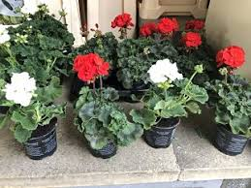

Year 3

Design and Technology

* Create a fruity sculpture. 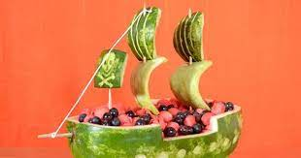

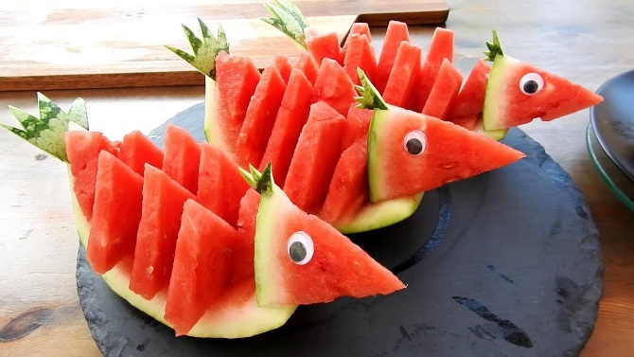

Geography

* Choose your favourite fruit and locate the journey is takes from the tree or plant to your plate.

Maths

* Can you identify obtuse, acute or right angles in your home? Make a list.

English

* Write a recount of an outing with your family.