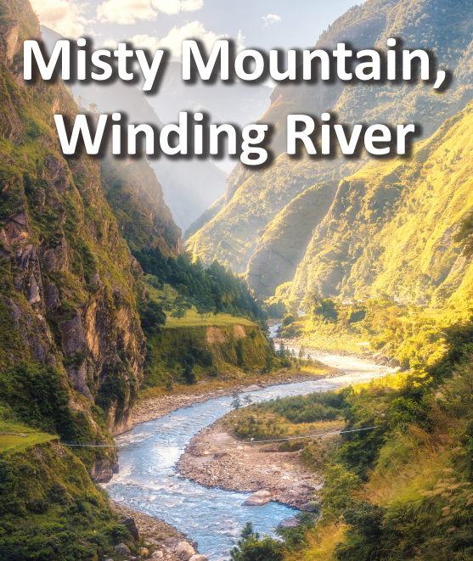

**Art and Design**

* Practice different types of stitching at home: running stitch, cross-stitching and blanket stitch.
* Practice embroidery stitching using old buttons, sequins or anything that you may have.
* Create a 3-D food model of a mountain, mountain range or a particular local hill, using ingredients of your choice. You could use jelly, cake, or even mashed potato! Who can make the highest structure? Or the most realistic one? Take a picture to compare with your classmates’ models.

**Literacy**

* Choose one worldwide river to learn about using information books and the internet. Write a leaflet about your chosen river to record your findings. Include a title, headings, pictures and facts. Once complete, share your work with a family member.
* Create fact files about famous mountaineers such as George Mallory, Sir Edmund Hilary and Reinhold Messner.
* Write a poem inspired by hills, rivers or mountains. Read ‘Where go the boats’ by Robert Louis Stevenson or ‘Mountain Peak’ by Harriet Earis for ideas.

**Maths**

* Keep practicing your multiplication and division facts for each times-table (up to 12s).

**Geography/History**

* Use a range of sources to learn about rivers. Find out how rivers form, the three stages of a river, how rivers change the landscape and how people use them. Create a mind map to organise and record your findings.
* Find 10 worldwide mountains, including mountains in the United Kingdom. Mark and label the mountains on a world map and include a key.
* Use a range of sources to learn about rivers. Find out how rivers form, the three stages of a river, how rivers change the landscape and how people use them. Create a mind map to organise and record your findings.