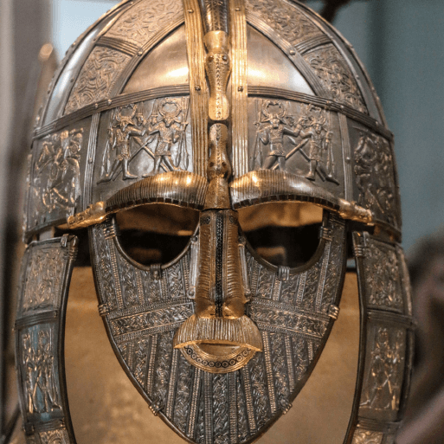

**Literacy**

* This term, we are reading the book called The Firework-Maker’s Daughter. We will be focussing on improving our skills in vocabulary, inference, predictions, retrieval and summarising.
* We will also be writing a character description of the main character in our story Lila. To do this, we will be looking at key features to include in this piece of writing. Later in the term, we will also be working on writing instructions, and improving our grammar knowledge. We will be ending our half-term by creating poems.

**Maths**

Throughout this half-term, we will be:

* Revising place value, with numbers up to 10,000 and comparing up to 5-digit numbers
* Learning Roman Numerals up to 100
* Partitioning numbers, as well as rounding to the nearest 10, 100 and 1,000
* Estimating and finding 1, 10, 100, 1,000 more or less of a number
* Adding and subtracting up to two 4-digit numbers
* Continuing to practice times tables.
* Using squares to count an area and comparing the areas of different shapes.

**PE**

* This term, PE will be on a **Friday afternoon**. Please ensure that children still come into school wearing their PE kit, including a Brady PE top.

**Topic**

* In History, we will be travelling through the Anglo-Saxon and Viking period, looking at how invasion affected life both on mainland Europe and in Great Britain.
* In Art we are creating geometric patterns whilst we learn about Islamic Art styles.
* In Science, we will be learning about States of Matter, comparing the forms of solids, liquids and gases.
* In Computing, we will be studying what it means to programme, and creating our own educational games.
* We will also be continuing to study RE, Music, PSHE and French, as well as having time dedicated to handwriting and spelling.

Invasion