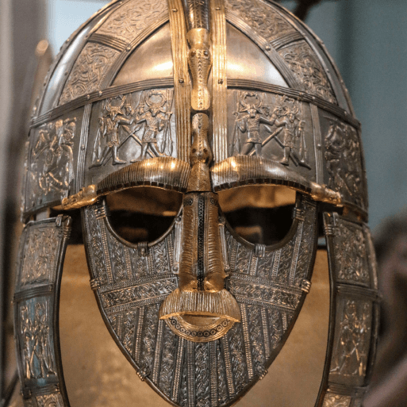

**PE**

* This term, PE will continue be on a Thursday morning. Please ensure that children still come into school wearing their PE kit.

**Literacy**

* This term, we are reading the novel The Lion, the Witch and the Wardrobe by C.S. Lewis. We will be continuing to develop our skills in defining vocabulary, inference, making predictions, retrieval and summarising/sequencing events.
* In English, we will be exploring two new pieces of writing skills. We will begin by writing a Playscript, based on an Anglo-Saxon scene, as well as a Newspaper Article based on the invasion of Britain by the Vikings.

**Maths**

Throughout this term, we will be:

* Learning to multiply by 11 and 12, multiplying by 3 numbers and factor pairs.
* We will also be practicing written methods and efficient methods of multiplication.
* To end our unit on multiplication and division, we will be multiplying 2 and 3 digit numbers by 1, as well as dividing them also.
* Our second unit will be focussed on area, before moving on to begin fractions.
* Continuing to practice our specific times tables for the weekly test (still on Thursday mornings).

**Topic**

* In History, we will be travelling through the Anglo-Saxon and Viking period, looking at how invasion affected life both on mainland Europe and in Great Britain
* In Art, the children will be learning the skill of printing and creating their own patterns using materials such as tiles, rollers and ink paint.
* In Science, we will be learning about Sound, including parts of the ear.
* In Music, the children will be learning a song called Stop! which is about anti-bullying.
* For our RE lessons, our topic is called ‘Who should Inspire us?’, in which we will look at various prolific figures from different religions.
* The children will continue to learn French weekly, focussing on the topics of Food and At School.

Invasion