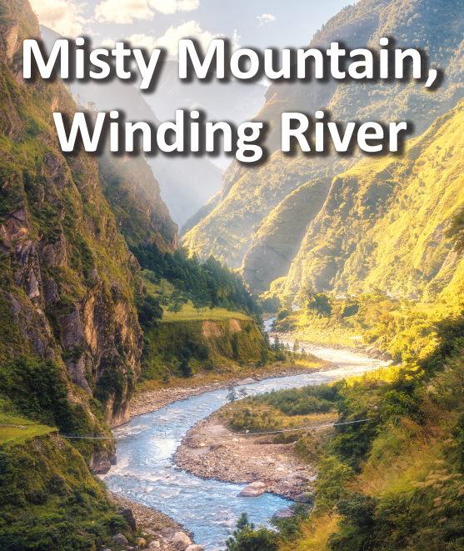

**Literacy**

* Choose one worldwide mountain to learn about using information books and the internet. Write a leaflet about your chosen mountain to record your findings. Include a title, headings, pictures and facts. Once complete, share your work with a family member.
* Create a narrative poem about a mountain expedition
* Create your own map of a trail for a mountain journey.

**Maths**

* Keep practicing your multiplication and division facts for each times-table (up to 12s).
* Decimals, time and money topic revision

**Geography/History**

* Use a range of sources to learn about mountains. Find out how rivers form, the three stages of a river, how rivers change the landscape and how people use them. Create a mind map to organise and record your findings.
* Find 10 worldwide mountains, including mountains in the United Kingdom. Mark and label the mountains on a world map and include a key.
* Use a range of sources to learn about rivers. Find out how rivers form, the three stages of a river, how rivers change the landscape and how people use them. Create a mind map to organise and record your findings.

**Art and Design**

* .Create your own mountainous landscape drawing.
* Paint a picture of your favourite animal.
* Build a 3-D model of a mountain using a range of materials such as clay, paper Mache, balloons and card.