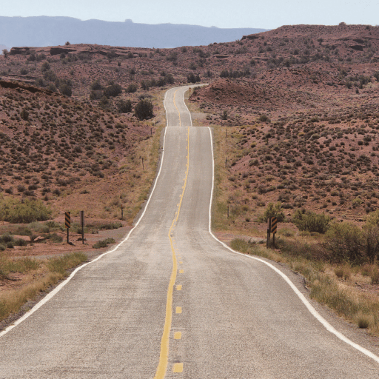

**Various**

* Use online sources to research and create a timeline of Native American history. Decide which events are most important, and write a caption to go with each date, explaining what happened.
* Native American symbols can vary in meaning from one tribe to another and across different regions. Symbols were used for a variety of reasons and are depicted on numerous objects. What can you find out about this mysterious language?
* Find out about the Battle of the Little Bighorn. Why is it such an important historic event?
* There have been many U.S. presidents over the last 100 years. How many can you find? Write a short biography about one of them.
* Make a playlist of different American songs you could listen to on your road trip. Make sure you include songs from a range of genres, such as blues, jazz, country, rock, hip hop and rock and roll.
* Plan a second road trip, this time around South America. Plan your route on a digital map and write an itinerary.
* Help prepare a United States-themed evening meal by writing a shopping list for parents and carers. Report back to others using video or photographic evidence. What did you have to eat?

**Maths**

* Keep practicing your times tables at home at least once a week. This includes going onto Times Table Rockstars at least once a week too.
* Ask your family to challenge you and convert fractions into decimals- what is 1/10 as a decimal?

**Literacy**

* You must continue to read at least 5 times a week at home. This can be any days that suit your timetable at home, but an adult must sign the child’s reading record after they have heard them read.
* Write a speech for a tribal chief to make to his tribe. It could be to get them ready to fight against another tribe or to announce a forthcoming marriage.
* Research the story The Indian in the Cupboard by Lynne Reid Banks. Create an advertisement to sell the cupboard that makes toys come to life in the story.
* Research the significance of words and phrases (such as harmony, nature, spirit, natural, soul, force of nature, orenda, dream and vision) to the Iroquois culture. Use drawings, photographs and text to create a digital presentation to record and share your findings.

Road Trip USA!