**Brady Primary School**

**Art/DT Policy**



‘Inspiring teaching for ambitious learners’



Policy Created- October 2024

Reviewed – September 2025

**Aims of Brady Primary School**

**“Inspiring teaching, for ambitious learners”**

At Brady Primary School our ethos is built around our 4 core values of Dedication, Inspiration, Respect and Achievement. These help us to provide a safe, caring and stimulating environment, which offers opportunities:-

* For everyone within the school to reach their full potential and develop self-worth, self-confidence, the ability to take responsibility for their own individual actions, and resilience.
* For everyone within the school to have a sense of wonder, an enthusiasm for learning and help children to develop as independent thinkers and learners with enquiring minds.
* To encourage and develop a respect and understanding for others.
* To develop all partnerships, small and large, from the individual parent to the wider community and beyond to support children’s learning.
* To give children access to a broad and balanced creative curriculum to attain the highest possible standards in relation to prior attainment through assessment, teaching and learning.

**Equal opportunities and Inclusion**

At Brady Primary School we believe that every child is entitled to equal access to the curriculum, regardless of race, gender, class or disability. We are committed to promoting learning and teaching environments, for all that embed the values of inclusive educational practices. Through a child-centered approach, we aim to ensure that education is accessible and relevant to all our learners, to respect each other and to celebrate diversity and difference.

**Contents of this Policy**

* The teaching of Art/DT at Brady Primary School
* The assessment of Art/DT at Brady Primary School

The teaching of Art/DT at Brady Primary School

The Art and Design Technology curriculum aims to foster creativity, build upon critical thinking, and practical skill development in students. Artistic expression and design thinking are essential components of a well-rounded education. Our Art and DT curriculum provides children with opportunities to develop and extend

their knowledge and skills and to be able to express their individual interests, thoughts and ideas. Over time, children will develop their knowledge and skills within a range of medias such as drawing, painting, printing, collage, textiles and sculpture.

At Brady Primary School, the Art/DT curriculum ensures pupils are given the opportunity to:

* Use a range of materials creatively to design and make products.
* Develop a wide range of art and design techniques in using colour, pattern, texture, line, shape, form and space.
* Produce creative work, exploring their ideas and recording their experiences.
* Use drawing, painting and sculpture to develop and share their ideas, experiences and imagination.
* Learn about the work of a range of artists, craft makers and designers, describing the differences and similarities between different practices and disciplines, and making links to their own work.
* Improve their mastery of art and design techniques, including drawing, painting and sculpture with a range of materials (for example, pencil, charcoal, paint, clay).
* Learn about great artists, architects and designers in history.
* Create sketchbooks to record their observations and use them to review and revisit ideas.
* Become proficient in drawing, painting, sculpture and other art, craft and design techniques.
* Evaluate and analyse creative works using the language of art, craft and design.

All children should have access to basic Art and DT materials in their own classroom, including paintbrushes, paper, glue and scissors. Materials which are not used on a daily basis, such as clay, printing ink, or large sculpture materials, will be ordered by the subject leader and distributed to the necessary year groups. Additional resources that can be used across all year groups are stored in Art and DT storage cupboards.

The subjects follow Cornerstones (Curriculum Maestro), which is the scheme used to plan and teach every lesson.

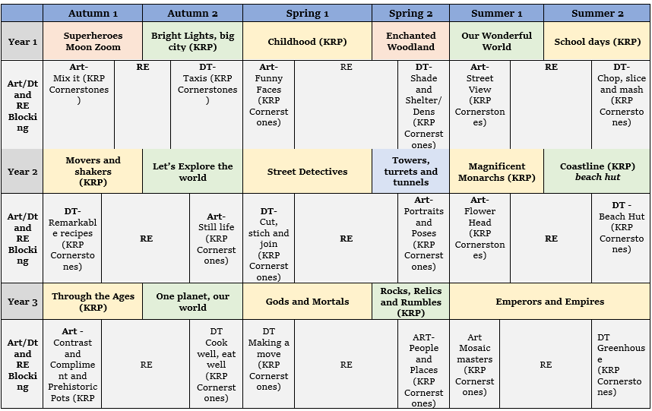

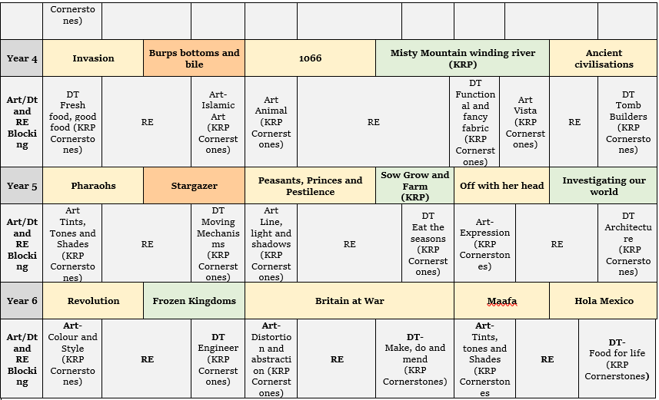

The assessment of Art/DT at Brady Primary School

At Brady Primary School, pupil progress in KS1 and KS2 is assessed through ongoing formative assessments based on participation, skill development, and creativity.

The subject leader role also involves the monitoring of pupil progress through pupil questionnaires, interviews and work sampling. Below is an example assessment document.

|  |  |  |
| --- | --- | --- |
| Year Group:  Term:  Focus: | | |
| Working Below:  I am *starting* to use and control more specialist media with *some confidence* to explore ways in which they can be applied to achieve particular effects. I can make drawings that include *some* detail and context. | Working At:  I can use and control more specialist media to explore ways in which they can be applied to achieve particular effects. I can make drawings that include detail and context. | Working Above:  I can *confidently* use and control more specialist media to explore ways in which they can be applied to achieve particular effects. I can make drawings that include fine detail and context. |