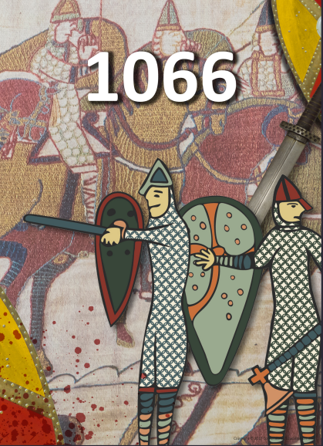

**Literacy**

* We will be writing a diary entry for our first piece of writing this term. We will be using the picture book ‘Flotsam’ as our inspiration, following the pictures taken with an underwater camera and delving into the weird and wonderful world of sea life.
* We will also be writing a newspaper article linked to our topic this half term of 1066. The children will create a newspaper article about the Battle of Hastings.
* This term, we are reading the novel The Lion, the Witch and the Wardrobe by C.S. Lewis. We will be continuing to develop our skills in defining vocabulary, inference, making predictions, retrieval and summarising/sequencing events.

**Maths**

Throughout this half-term, we will be:

* Finding factors and factor pairs of numbers and using them to multiply
* Multiplying and dividing by 10 and 100
* Multiplying and dividing 2 and 3 digit numbers by a 1 digit number
* Measuring in kilometres and metres
* Finding the perimeter of different polygons.

**PE**

* This term, PE will be on a **Friday afternoon**. Please ensure that children still come into school wearing their PE kit, including a Brady PE top.

**Topic**

* In History, we will be travelling back to 1066, learning all about a changing England, shaped by shires, protected by castles and ruled by foreign knights.
* In Art we are looking at the history of animals in art, and using that to create our own sculptures.
* In RE, we will begin to learn about what religion teaches us about the natural world and why we should take care of it.
* In Science, we will be learning about Sound, learning about how it travels and how it changes.