**Brady Primary School**

**RE Policy**





Contents

Introduction

Intent

Aims

Statutory requirements

Definition

Implementation

Curriculum

Organisation and planning

Roles and responsibilities

Parents’ right to withdraw

Impact

Staff training

Monitoring and Assessment

**Introduction**

Religious Education is an important element in the broad and balanced curriculum that we aim to provide at Brady Primary School. Through our RE curriculum we provide opportunities to develop pupils knowledge and understanding of world religions and reflect on the challenging questions that it provokes. As stated in the Agreed Syllabus for Religious Education for Havering, Religious Education contributes dynamically to pupils and young people’s education in schools by provoking challenging questions about meaning and purpose in life, beliefs about God, ultimate reality, issues of right and wrong and what it means to be human.

All schools must provide a curriculum that is broadly based, balanced and that meets the needs of all pupils under section 78 of the Education Act 2002. Religious Education in this country is locally agreed within each Local Authority and strives to be relevant to the lives of young people of all faiths and none.

This RE policy is informed by existing guidance on Religious Education (Agreed Syllabus for Religious Education for Havering 2015-2021).

Intent

Aims

The aims of RE at our school are to ensure that pupils:

* Know about and understand a range of religions and worldviews, including knowledge of both religious and non-religious world views
* Are able to describe, analyse and explain different beliefs and practices
* Can develop their knowledge, understanding and skills around religions and the wider world
* Are prepared and ready for the ever-changing wider world
* Are able to articulate beliefs, values and commitments clearly to explain theirs and others views and values.

Statutory requirements

RE is a statutory subject and forms part of the core curriculum for all Key stage 1 and 2 pupils. Our school RE curriculum is based on the Havering Local Authority’s Agreed Syllabus (SACRE) and it meets all the requirements set out in that document. The Education Act 1996 states that an Agreed Syllabus must reflect the fact that the religious traditions in Great Britain are in the main Christian, whilst taking account of the teachings and practices of the other principal religions represented in Great Britain.

Definition

Religious education contributes dynamically to children and young people’s education in schools by provoking challenging questions about meaning and purpose in life, beliefs about God, ultimate reality, issues of right and wrong and what it means to be human. In RE, pupils learn about and from religions and worldviews in local, national and global contexts, to discover, explore and consider different answers to these questions. They learn to weigh up the value of wisdom from different sources, to develop and express their insights in response, and to agree or disagree respectfully. Pupils should gain and deploy the skills needed to understand, interpret and evaluate texts, sources of wisdom and authority and other evidence. They learn to articulate clearly and coherently their personal beliefs, ideas, values and experiences while respecting the right of others to differ.

The core purpose of RE is to engage pupils in exploring and responding to challenging questions raised by religion and worldviews, so that they can develop the knowledge, understanding and skills needed to appreciate and appraise varied responses to these questions, including their own.

The purpose of RE reflects the process at the heart of the Havering Syllabus, exploring and responding. The study of religion and worldviews is undertaken both for its own sake, but also for the impact it can have in the lives of pupils.

The three pathways of expression, identity and questioning are at the centre of the Havering Syllabus. The purpose of RE encompass these three pathways providing continuity for pupils in Havering as they study religion and worldviews.

Implementation

Curriculum

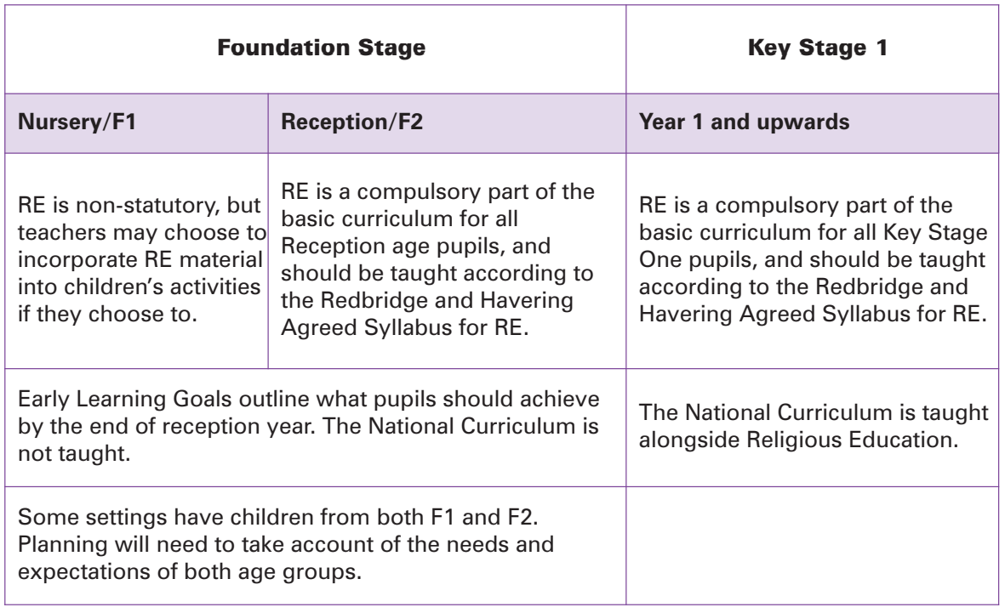Every child at Brady has a right to share their beliefs, religions and/or worldviews and to respect those of others too. Our RE curriculum follows the Havering scheme of work, which aims to provide opportunities for all pupils to learn and achieve. It promotes pupil’s spiritual, moral, social and cultural development and prepares pupils for the opportunities, responsibilities and experiences of life. It is underpinned by the school’s core values.

The Havering Scheme sets out a programme of study for EYFS, KS1 and KS2 to ensure a systematic and coherent journey of the study of Christianity across each key stage and the introduction to the other principle religions by the end of KS2.

RE at Brady offers a safe and secure space during curriculum time for reflection, discussion and debate, allowing pupils to build their reasoning and cognitive skills.

Organisation and planning

RE will be taught through:

* Discreet individual lessons
* Whole school/Key Stage celebrations such as RE days or multi-cultural themed events
* Assemblies, class discussions and circle time
* Cross-curricular opportunities; pupils’ skills in Literacy will be enhanced, as well as problem-solving, decision-making and interpersonal skills.

Our long and medium term plans ensure that there is progression throughout the school and that pupils are building upon knowledge learnt in previous years. The topics are designed so that pupils develop knowledge and understanding of the principal religions in the UK and Christianity is taught as a core religion in both key stages.

Our Local Authority based scheme of work ensures that pupils have encountered and explored the religions through the EYFS and Key Stages 1 and 2. We use a combination of teaching RE through the creative curriculum and as a separate subject, depending on the material which has to be covered.

Short term planning of individual lessons is organised by the class teacher. The RE Subject Lead is available to help with this. When planning each unit of work the teacher will identify which parts of the programme of study are to be the focuses. The work planned must be relevant to the needs of all pupils.

Roles and responsibilities

Head of School

The governing board will approve the RE policy, and hold the head teacher to account for the implementation of this.

RE lead

The RE lead (Miss Booth) is responsible for:

* Ensuring that RE is taught consistently and in accordance with our scheme of work across the school.
* Ensure attainment and progression across the school
* Being available to advise and work alongside colleagues for successful planning, delivering and assessment of RE
* Co-ordinating RE based events

Staff

Staff are responsible for:

* Delivering RE using sensitive and inclusive approaches
* Modelling positive attitudes towards RE
* Monitoring progress
* Responding to the needs of individual pupils
* Assessment of RE

Pupils

Pupils are expected to engage fully in RE and to treat others with respect and understanding during discussions and debates. Pupils are expected to work to their full potential and demonstrate clearly their knowledge and understanding of each lesson.

Parents’ right to withdraw

At this school it is our practice to talk to parents to ensure that they understand the aims and value of the RE curriculum before honouring the right of withdrawal from RE. Any parent who wishes to withdraw their child is expected to consult the headteacher.

Parents hold the right to withdraw their children from RE on the grounds that they wish to provide their own religious education. (School Standards and Framework Act 1998 S71 (3)). This will be the parents’ responsibility.

**Impact**

Staff training

The training of RE is included in our continuing professional development (CPD) calendar and whole school training needs are included in action plans. Our school ensures they are kept informed of relevant changes to aspects of RE by regularly attending LA meetings. The RE lead (Miss Booth) is also always available to provide support and advice should members of staff require this.

Monitoring & Assessment

The delivery of RE is monitored by the RE lead through:

* Pupil voice/ pupil discussions
* Learning walks
* Lesson observations
* Book looks
* Professional discussions with members of staff

This is to ensure the following:

* Curriculum delivery is accurate and effective
* The impact of RE in the classroom
* Demonstration of progress and attainment
* Understanding resource and staff training requirements

In Early Years, pupils are assessed against EYFS Development Matters in Nursery and Reception against Understanding the World (UW).

Teacher assessment is carried out on an ongoing basis using the Target Tracker assessment programme. The Class Teachers are responsible for the day-to-day organisation of the curriculum. They monitor the weekly lesson plans, ensuring that all classes are taught the full requirements of the agreed schemes of work, and that all lessons have appropriate learning objectives. This policy is monitored by Brady Primary SLT and will be reviewed every year by staff.

## Policy details Date Name

Policy approved by Senior Leadership:

Policy approved by Linked Governor

Date of next review: