DATE: Friday 14th February 2025

SUBJECT: World Book Day 6th March 2025

Dear Parents/ Carers,

This year World Book Day falls on Thursday 6th March 2025. We are going to ask the children to come into school dressed as their favourite book character e.g. The BFG or genre of book e.g. a scientist from a non-fiction book. The children are welcome to bring in the book, magazine or other form of reading material to showcase their favourite character or style of reading. There will be a prize for each class for the best home-made outfit! During the day, the children will be taking part in a range of activities to promote the love of reading including online events and assemblies.

Reading Café

Please join us for the first 30 minutes of the day for a reading café! Parents are invited into classes to join their children exploring books. You are welcome to bring a book to share from home with your child and friends and see all of the fantastic costumes that have been made! We apologise but no younger siblings are allowed to attend this event. If you have more than one child in school, we suggest 10 minutes per class to allow time with your children.

Brady’s Reading River- Family Project

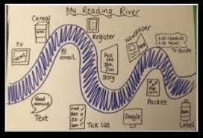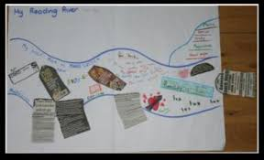

In school across the week of 3rd March, we are going to be creating a class reading river. We are going to think about all the times that we read as part of our daily life. As a family we are going to ask you to create a reading river at home. The children can take pictures/ draw or write about the things you read across a week. This could be- storybooks, recipes for cooking, road signs on the way to school, labels on packaging in the supermarket. These can be any size paper that you wish and need to come to school on Thursday 6th March to be passed to the class teacher to used in discussion and displays.

World Book Day £1 tokens

The children will also be receiving a £1 World Book Day voucher the week after half term. These can be used towards the price of a book from retailers such as Tesco, Asda and Waterstones. You have until the 25th March 2025 for this to be used in store.

**Happy Reading!**

Mrs Moseley- Reading Lead