23rd September 2024

Dear Parent/Carer,

SUBJECT: (BENEFIT RELATED) FREE SCHOOL MEALS.

Last year, free school meals were extended to children in Key Stage 2 (Years 3-6) courtesy of the Mayor of London. The initiative, dubbed ‘Mayor's Meals’, is continuing for another year which means your child will still receive a tasty and nutritious meal through the 2024-25 academic year.

You may be aware that, regardless of Mayors Meals, all children eligible for Pupil Premium payments are still eligible to apply for this funding. Pupil Premium funding is a grant from the government paid directly to schools and used to improve educational outcomes for disadvantaged pupils. Each Pupil Premium payment grants the school an extra £2,010\* per eligible pupil which contributes towards this pot of money.

Signing up for Pupil Premium is fast and easy using London Borough of Havering’s citizen’s portal\*\*.

* Scan the QR code below:

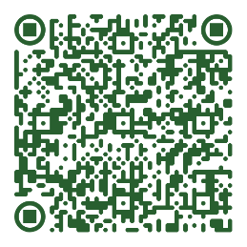

* Enter a few details (such as your National Insurance number)
* Approval is granted in seconds
* *That’s it!* Your child's school will get much needed extra funding for better learning experiences.

Register before Thursday 17th October 2024 to ensure your child’s school receives funding for the 2024/25 financial year.

*\*£1,430 Pupil Premium funding + £530 in school meal payments*

Yours sincerely

MNunn

Mr Michael Nunn