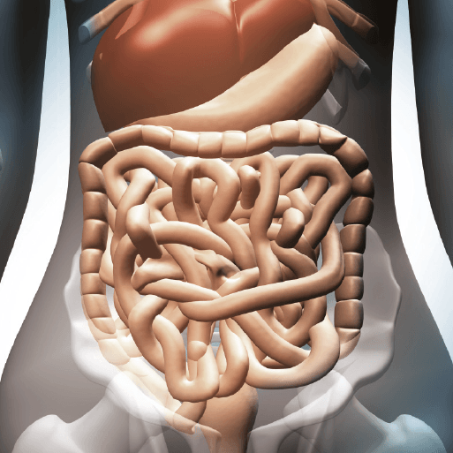

**Various**

* Find a mirror and have a look at your teeth. Notice the different sizes and shapes as you look from the front to the back of your mouth. Humans have four types of teeth: incisors, canines, premolars and molars. Use information books or the internet to complete a table about the four types of teeth. Include the name of each tooth, what the tooth looks like, where it is found and its function.
* Research healthy eating online or using information books. Write four reasons why it is important to eat healthily. Think about the impact that food has on digestion and the human body.
* Think about what you ate yesterday. Write a food diary, recording what you ate, whether the snack or meal was healthy or unhealthy and explain why. Look at your food diary and consider how you could change your diet to make it healthier. Write three healthy changes that you could make to your diet, based on what you ate yesterday. Afterwards, you could explore healthy recipes and snacks in a cookbook.
* Draw a diagram showing the main parts and organs of the human digestive system, including the mouth, oesophagus, stomach, small intestine and large intestine. Use your existing knowledge, the internet or information books to help you to label each part. Research and record the functions of the oesophagus, stomach, small intestine and large intestine.
* Use your research skills and knowledge of the digestive system to answer these questions: Why is digestion important? How does food move through the digestive system? What is the purpose of teeth? What happens to food when it is in the stomach? What is the purpose of the rectum?
* One way in which a person can stay healthy is to take care of their personal hygiene. Write a list of actions that people can do to keep themselves clean and preserve health. Find out why the aspects of personal hygiene that you have listed are important.

**Maths**

* Keep practicing your times tables at home at least once a week. This includes going onto Times Table Rockstars at least once a week too.
* Test your adults at home on their multiplication and division skills- could they answer more questions than you in any given time? Have a competition between as many of you as you can!

**Literacy**

* You must continue to read **at least 5 times a week at home.** This can be any days that suit your timetable at home, but an adult must sign the child’s reading record after they have heard them read.
* Use your knowledge of teeth to design and create an information poster, teaching other children how to look after their teeth and why it is important. Think about the important messages that you want to give about oral hygiene. Can you create a catchy slogan?

Burps, Bottoms and Bile