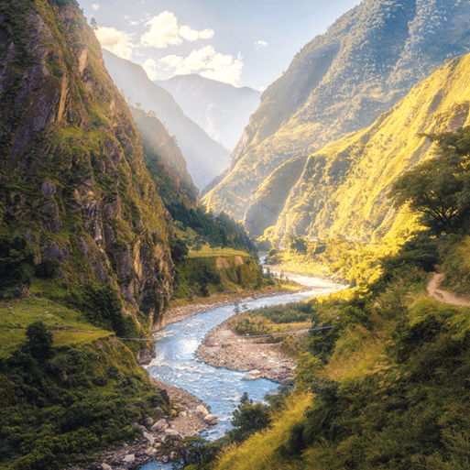

Misty Mountain,

Winding River.

**Other**

* Enjoy a riverside or hilltop walk with your family. Before your outing, explore the area using an Ordnance Survey map to examine the contour lines, grid references and other features. When you arrive home, write a diary entry about the day. Include the date, events in chronological order, facts and your thoughts and feelings.
* Many people use rivers and mountains for leisure and sporting activities. Answer the questions and complete the tasks below, using a range of sources to help.
* What leisure and sporting activities do people do on rivers? • Choose three of these activities and list the equipment required. • Hiking, rock climbing and fell running are activities that people carry out on hills, rocky outcrops and mountains. Write a definition for each activity.

**Maths**

* Keep practicing times tables every day
* Test one of your family members on their division facts- could you beat them in a quick-fire quiz?!
* Measure the length of household items such as a TV or a chopping board- how do the lengths compare?

**Geography/History**

* Use a range of sources to learn about rivers. Find out how rivers form, the three stages of a river, how rivers change the landscape and how people use them. Create a mind map to organise and record your findings.
* Find 10 worldwide mountains, including mountains in the United Kingdom. Mark and label the mountains on a world map and include a key.
* Use an atlas, map or online tool, such as Google Earth, to find a range of rivers worldwide, including rivers in the United Kingdom. Trace each river’s journey by locating the source and following the river’s course to its mouth.

**Literacy**

* Choose one worldwide river to learn about using information books and the internet. Write a leaflet about your chosen river to record your findings. Include a title, headings, pictures and facts. Once complete, share your work with a family member.
* Find out what defines a mountain, how they form, different types of mountain and mountain habitats. Choose a topic relating to mountains and create an information poster to record your findings.

**Art and Design**

* Create a collage-style version of an image similar to the one on this page, including a river and a mountain. You can use tissue paper, pens/pencils, oil and any other materials you find. Be as creative as possible!