Year 3 Homework
Friday 28th January 2022
Spellings
Your spelling quiz will be on Friday 4th February
Please use your Spelling Shed login which can be found in the front of your reading record to practice.
Group 1 – Mrs Staples Group 2 – Mrs Agates
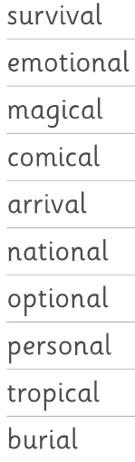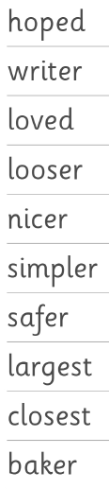

Times Tables
Your timetables quiz will be on Friday 4th February.
Group 1 – 3x, 4x, 8x
Group 2 – 3x, 5x
Please use TT Rockstars to get some practise at home as well as writing them out.

Reading
Please continue to read at least 3 times a week at home to a grown up.

