Thursday 20th January 2022
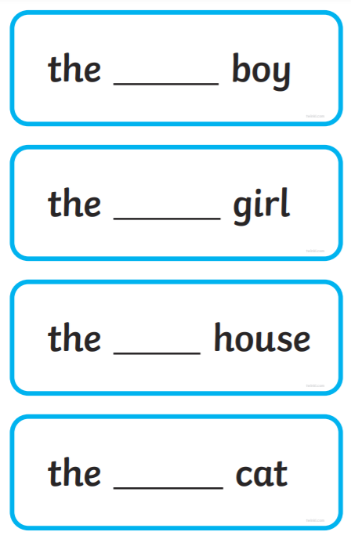
L.O: I can use adjectives.

Now write a sentence using your examples above.

_______________________________________________________________________________________
_______________________________________________________________________________________

Thursday 20th January 2022
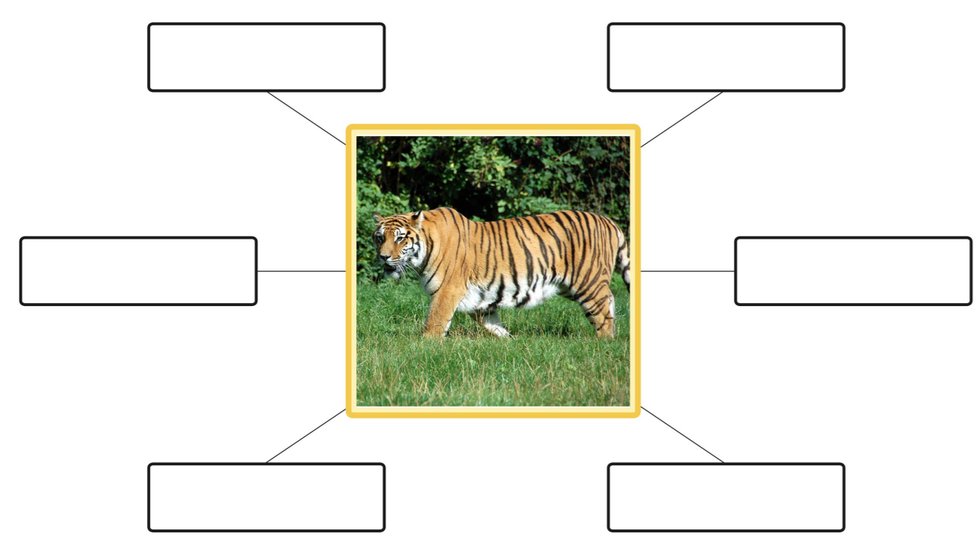
L.O: I can use adjectives.
tiger

Use these adjectives to write sentences about the tiger.
Thursday 20th January 2022
L.O: I can use adjectives.
tiger

Use these adjectives to write sentences about the tiger.

Thursday 20th January 2022
L.O: I can use adjectives.
and but or because so
tiger

Use these adjectives to write sentences about the tiger.

