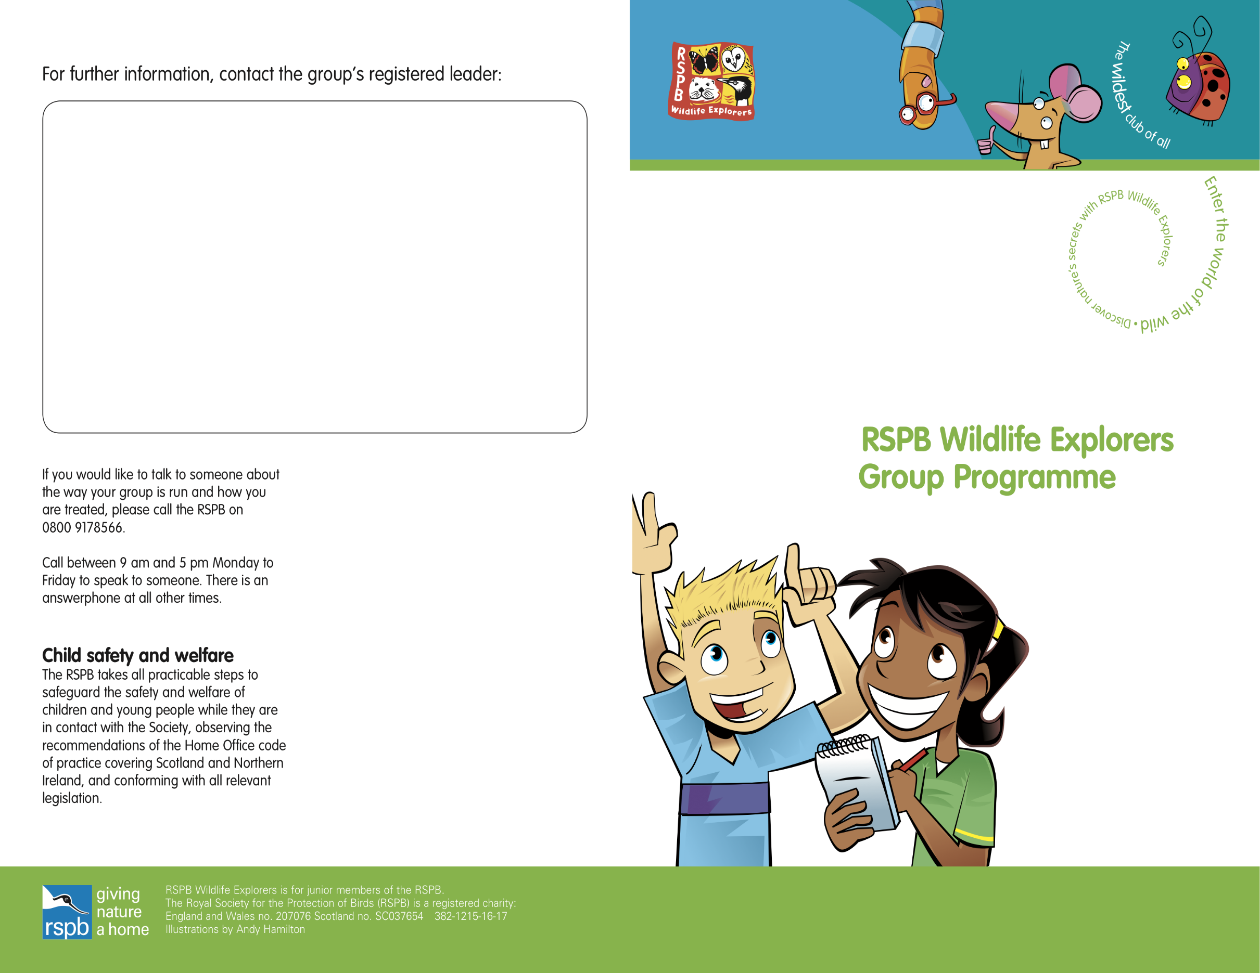
Rainham Marshes Wildlife Explorer Group
Kim Nicholas and Sam Alexander
Tel: 07811 062 883 / 07967 094 253
Email: kim.nicholas@rspb.org.uk
Rainham Marshes Wildlife Explorer group is for 8-12 year olds and unless advertised, meets every 2nd Saturday in the month between 10.00am and 12.00pm
Address: RSPB Rainham Marshes, New Tank Hill Road, Purfleet RM19 1SZ
Cost: £3.00 per child
£2.50 per child for RSPB members and annual subscription

RSPB Rainham Marshes Wildlife Explorers Club
Annual Program of Activities 2022:
Saturday 9th April Free Taster Day!
Explore the Rainham Marshes with binoculars (provided)
Saturday 14th May The Wonderful World of Mini Beasts
Discover the mini beasts who eat and sleep at Rainham Marshes
Saturday 11th June Rainham’s Feathered Friends
Create a water bath for woodland birds and learn how to identify, feed and care for them
Saturday 9th July Pond Dipping
Explore the amazing world of pond creatures: who eats who?
(NO AUGUST ACTIVITIES)
Saturday 10th September Love bugs
Give a bug a cosy home and build a giant bug hotel
Saturday 8th October What grows on trees?
Detectives wanted! Investigate with your magnifying glass the fantastic miniature world of lichens and mosses
Saturday 12th November Protect Your Hedgehogs
Build a snug hedgehog nest for our prickly friends
Saturday 10th December A Festive celebration
Bring your family to our Christmas ‘show and tell’.

Age group for members 8yrs -12rs
Our group meetings are fun and engaging. Whatever the weather, we go out exploring our local area with an emphasis on enjoyment, discovering nature and take action for nature.
We take your children on a journey to deepen their connection to nature.
Points to note:
- Please let us know you are coming! Contact via email or phone, contact details above
- What to wear? Clothes and sturdy shoes you don’t mind getting dirty or wet!
- What to bring? Sunscreen for sunny weather. Bring your water bottle.
- The group is run as part of the RSPB and covered by their insurance, policies and procedures
- All leaders have a DBS check
- Our First Aiders are: Kim Nicholas and Steven Spowart
- Parents/carers need to complete the RSPB Consent Forms before children attend their first monthly meeting
- Our Assistant Leaders are Wendy Beach, Rachel Foxley and Steven Spowart
Arriving and leaving procedures:
- Please meet the group leaders at Visitor Centre reception at 9.45 a.m. to sign the register
- The session will finish at 12.00 midday, everybody will be ready to leave at 12.15pm back at the Visitor Centre reception
- ‘MY-SPACE’: This is back at home where your children can continue their wildlife journey in a space of their own

