Brady Primary School

Marking and Feedback Policy





Dedication, Inspiration, Respect and Achievement

Policy Updated- September 2023

To be reviewed as required

- Policy Description
- Feedback and marking in practice
- In School
- Blended Learning
- Homework
- Marking Code

1. Policy Description

Aims
One of our core values in school is dedication, our marking and feedback in school is a key vehicle for developing this in our pupils.

Purpose
At Brady Primary, we recognise the importance of feedback as part of the teaching & learning cycle, and aim to maximise the effectiveness of its use in practice. We are mindful also of the workload implications of written marking, and of the research surrounding effective feedback. Our policy is underpinned by the evidence of best practice from the Education Endowment Foundation (EEF) and other expert organisations. EEF research shows that effective feedback should:
- redirect or refocus either the teacher’s or the learner’s actions to achieve a goal
- be specific, accurate and clear
- encourage and support further effort
- be given sparingly so that it is meaningful
- provide specific guidance on how to improve and not just tell students when they are wrong
Notably, the Department for Education’s (DfE) research into teacher workload has highlighted written marking as a key contributing factor to workload. As such, we have investigated alternatives to onerous written marking which can provide effective feedback in line with the EEF’s recommendations, and those of the DfE’s expert group which emphasises that marking should be:
- meaningful, manageable and motivating. We have also taken note of the advice provided by the NCETM
- that the most important activity for teachers is the teaching itself, supported by the design and preparation of lessons.

Marking at Brady Primary School should encourage, advise and challenge.
Our policy on feedback has at its core a number of principles:
- the sole focus of feedback and marking should be to further children’s learning;
- written comments should only be used where they are accessible to students according to age and ability;
- feedback delivered closest to the point of action is most effective, and as such feedback delivered in lessons is more effective than comments provided at a later date;
- feedback is provided both to teachers and pupils as part of assessment processes in the classroom and takes many forms other than written comments;
- feedback is a part of the school’s wider assessment processes which aim to provide an appropriate level of challenge to pupils in lessons, allowing them to make good progress.
- All pupils’ work should be reviewed by teachers at the earliest appropriate opportunity so that it might impact on future learning.

2. Feedback and marking in Practice
It is vital that teachers evaluate the work that children undertake in lessons, and use information obtained from this to allow them to adjust their teaching. Feedback occurs at one of three common stages in the learning process:

1. Immediate feedback – at the point of teaching
2. Summary feedback – at the end of a lesson/task
3. Review feedback – away from the point of teaching (including written comments where appropriate)

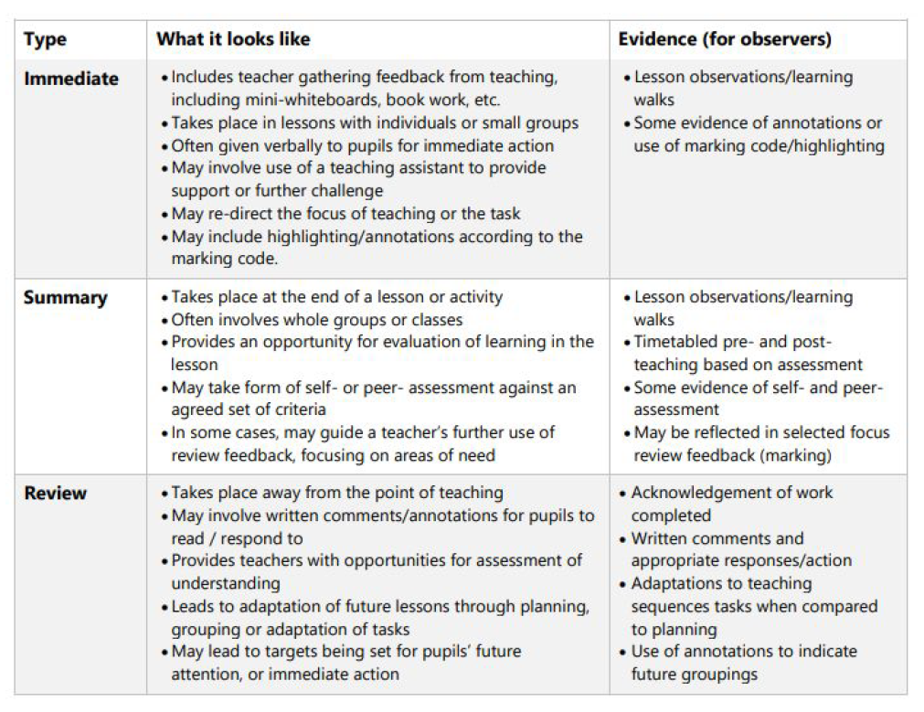
The stages are deliberately numbered in order of priority, noting that feedback closest to the point of teaching and learning is likely to be most effective in driving further improvement and learning, especially for younger pupils. As a school, we place considerable emphasis on the provision of immediate feedback. Where feedback is based on review of work completed, the focus will often be on providing feedback for the teacher to further adapt teaching. Methods of feedback may include:

When children self-mark their work:
- They should refer to the objective/success criteria and mark with green coloured pencil or green pen
- They should pick out parts of the work which are positive
- They should identify at least one improvement to work on, at an appropriate time, such as the start of the next lesson
- The work should clearly show that it was marked by the child

When children peer-mark (following modelling and training from the teacher):
- They should refer to the objective/success criteria
- They should identify positives
- They could work collaboratively to improve a sentence or a key area e.g. punctuation

3. In School marking
When the children are learning on-site the following marking and feedback will be implemented:

English
- Learning objectives to be highlighted with a date and initial of which adult has marked it for every lesson
- Children must self-assess against Learning objective
- Detailed feedback should be given to all children when learning new skills (minimum of once a week). This can be completed by teachers or TAs with their focus groups. All other feedback for that lesson can be given in a variety of ways: group feedback, class feedback, verbal feedback from teacher or TA, peer feedback, written feedback
- Cold writes are not marked and LO’s are not highlighted, they are simply dated and initialled.
- Hot Writes which occur at the end of a unit of work should not be marked in detail but are to be marked against a success criterion
- Next steps are identified from Hot Writes and are set as targets for the child
- Targets are made clear to children by the use of a sticky tab (MN to source). Teachers must write the target on this page with an example where necessary
- End of key stage year groups will use the interim frameworks to assess against, this may replace success criterion

Maths
- Learning objectives to be highlighted with a date and initial of which adult has marked it for every lesson
- Children must self-assess against Learning objective
- As and where appropriate, targets are set through the use of colour coded marking- if a child gets pink/ orange then this becomes their target- teachers are expected to unpick this and identify a critical skill(s) that is a gap e.g I can divide using TU, then the teacher should look at the basic skill required to approach this- ‘do you know your timestables?’. Therefore, the target will be timestable related. This would occur, potentially, once per unit etc. HA children who often achieve the learning objective teachers to select a skill/ target to help them achieve greater depth.
- Targets are made clear to children by the use of a sticky tab (MN to source). Teachers must write the target on this page with an example where necessary.

Science and foundation subjects
- Learning objectives to be highlighted
- Children must self-assess against Learning objective
- Marking is focused on subject skills and vocabulary
- Next steps are included where necessary

Early Years Foundation Stage
- Focus group feedback and marking

3. Blending Learning
Please refer to Blended Learning Policy

4. Homework

EYFS:
1 x Maths focus
1 X Topic focus
Weekly Reading minimum of 5 reads per week

From Y1-6 all children will complete:
1 x Maths focus- Timestables Rock Stars/ NumBots
1 x Spelling focus- set by teacher via SeeSaw
Weekly Reading minimum of 5 reads per week

Homework Maps are made available at the start of each half term- these are optional topics and are set via SeeSaw.

5.Brady Primary Marking Code

Highlight of the ‘I can’ | On every piece of work the LO must be highlighted, this shows when children have achieved (Yellow), partially achieved (Orange) and not achieved (pink) the objective
 | Assisted work stamper to show when children have worked with an adult in class. No stamp means that the work was completed independently.
ST | Supply Teacher (in addition to marking as per the policy)
VF | Verbal feedback (in addition to marking during the learning)
 | Pink highlight- Requires a response from a child. ‘Fix this please’ or ‘Now try this…’ ACTIVE VERB! (Children respond with a green pen- this must be acknowledged)
 | Orange highlight if it is partially met.
 | Yellow highlight- identifies effort, success, examples of where child has met the objective
This is what I need to see in your next piece of work
(NB- the next marking needs to say whether the child achieved or not)
Pupils Self-reflection | Clear understanding- happy face next to ‘I can’  Moderate understanding- straight face next to ‘I can’  Poor understanding- sad face next to ‘I can’
TARGET: | Targets are made clear to children by the use of a sticky tab (MN to source). Teachers must write the target on this page with an example where necessary.

This marking code is introduced as children are ready in Key stage One. In Year one the teacher supports the children in responding to marking using a ‘bubble’ to show them where their response should be.

