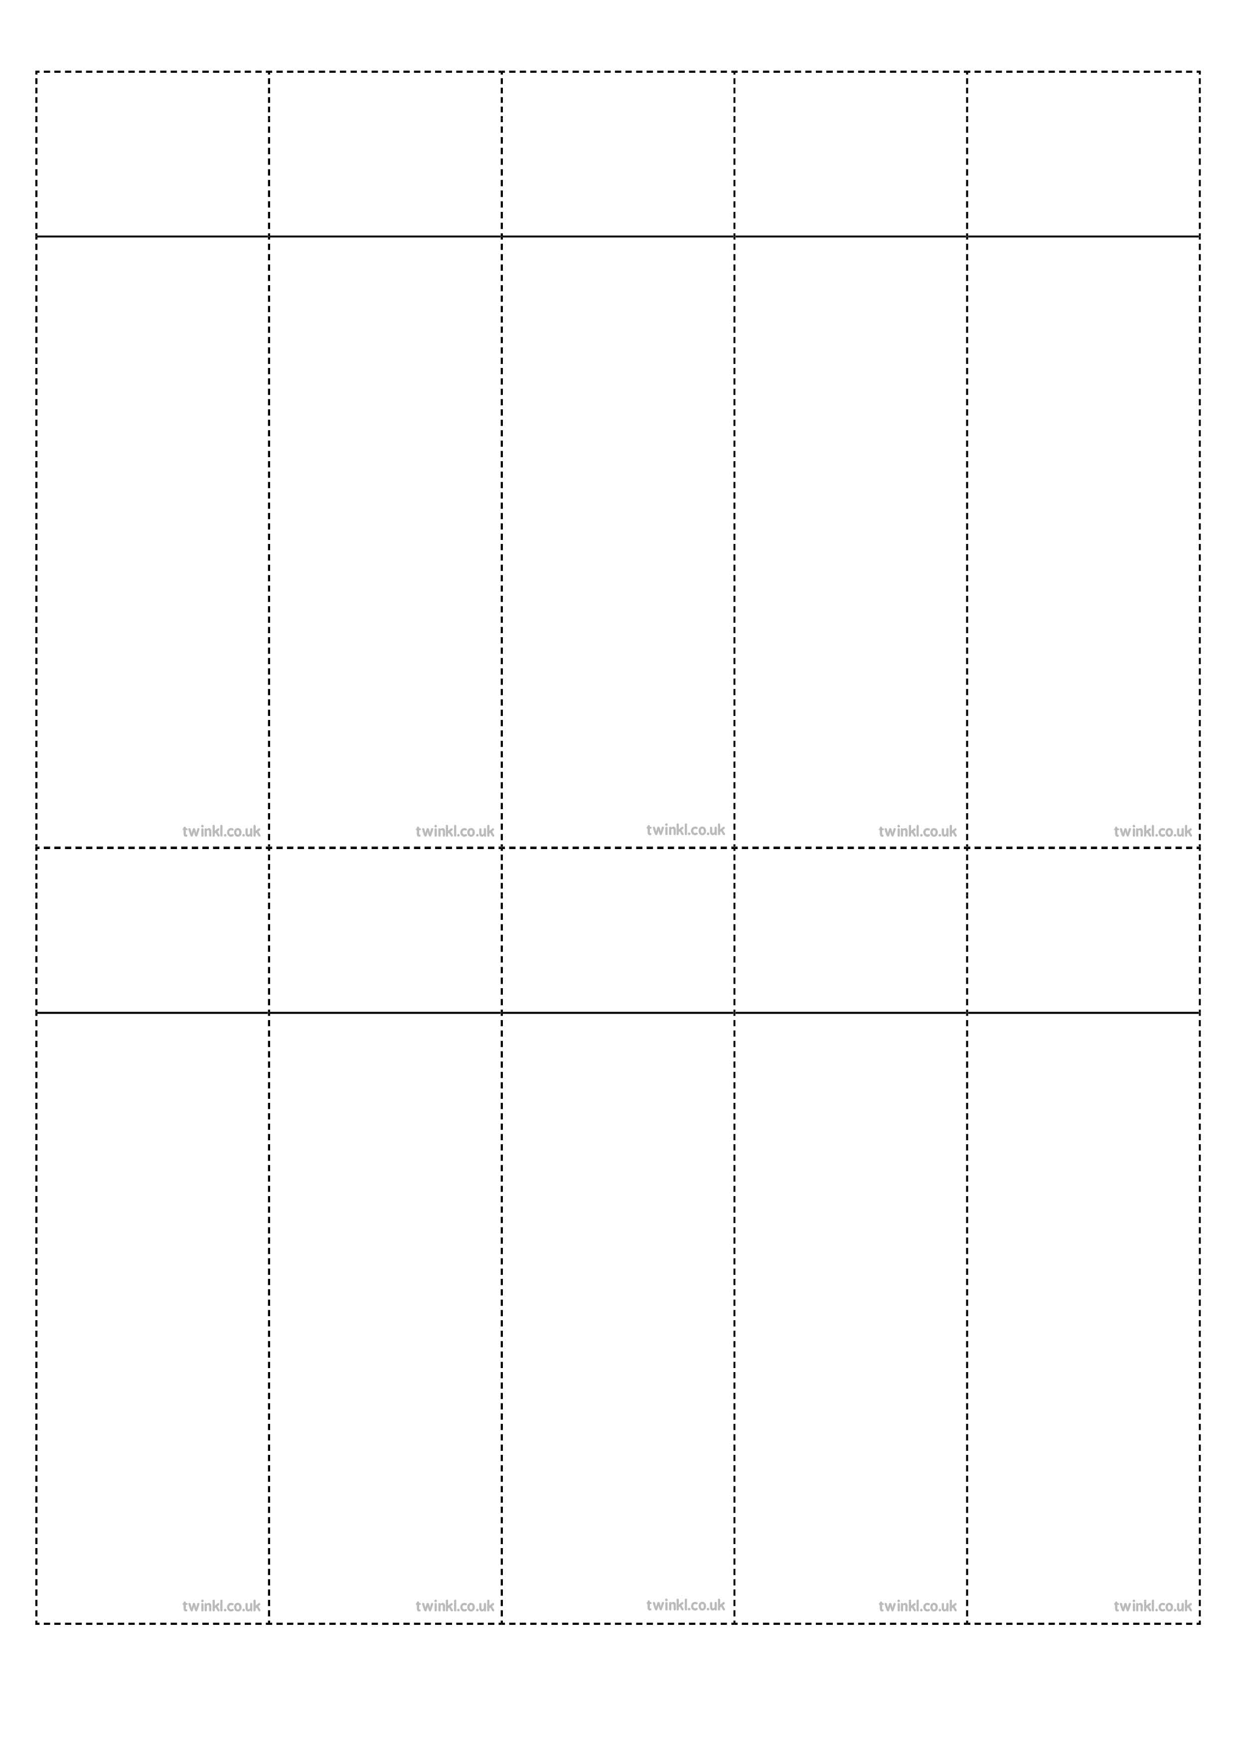
Week 1
Words with /aw/ spelt augh and au
caught
naughty
taught
daughter
autumn
clause
cause
astronaut
applaud
author
Week 1
Words with /aw/ spelt augh and au
caught
naughty
taught
daughter
autumn
clause
cause
astronaut
applaud
author
Week 1
Words with /aw/ spelt augh and au
caught
naughty
taught
daughter
autumn
clause
cause
astronaut
applaud
author
Week 1
Words with /aw/ spelt augh and au
caught
naughty
taught
daughter
autumn
clause
cause
astronaut
applaud
author
Week 1
Words with /aw/ spelt augh and au
caught
naughty
taught
daughter
autumn
clause
cause
astronaut
applaud
author
Week 1
Words with /aw/ spelt augh and au
caught
naughty
taught
daughter
autumn
clause
cause
astronaut
applaud
author
Week 1
Words with /aw/ spelt augh and au
caught
naughty
taught
daughter
autumn
clause
cause
astronaut
applaud
author
Week 1
Words with /aw/ spelt augh and au
caught
naughty
taught
daughter
autumn
clause
cause
astronaut
applaud
author
Week 1
Words with /aw/ spelt augh and au
caught
naughty
taught
daughter
autumn
clause
cause
astronaut
applaud
author
Week 1
Words with /aw/ spelt augh and au
caught
naughty
taught
daughter
autumn
clause
cause
astronaut
applaud
author

