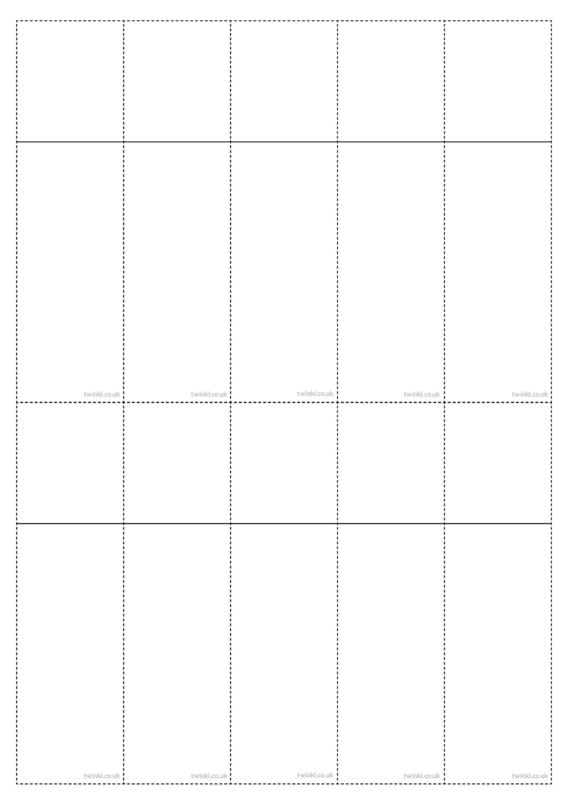
Week 4
Adding the prefix il- (before a root word staring with ‘l’) and the prefix ir (before a root word starting with ‘r’)

illegal
illegible
illogical
illiterate
illicit
irregular
irrelevant
irresponsible
irrational
irresistible
Week 4
Adding the prefix il- (before a root word staring with ‘l’) and the prefix ir (before a root word starting with ‘r’)

illegal
illegible
illogical
illiterate
illicit
irregular
irrelevant
irresponsible
irrational
irresistible
Week 4
Adding the prefix il- (before a root word staring with ‘l’) and the prefix ir (before a root word starting with ‘r’)

illegal
illegible
illogical
illiterate
illicit
irregular
irrelevant
irresponsible
irrational
irresistible
Week 4
Adding the prefix il- (before a root word staring with ‘l’) and the prefix ir (before a root word starting with ‘r’)

illegal
illegible
illogical
illiterate
illicit
irregular
irrelevant
irresponsible
irrational
irresistible
Week 4
Adding the prefix il- (before a root word staring with ‘l’) and the prefix ir (before a root word starting with ‘r’)

illegal
illegible
illogical
illiterate
illicit
irregular
irrelevant
irresponsible
irrational
irresistible
Week 4
Adding the prefix il- (before a root word staring with ‘l’) and the prefix ir (before a root word starting with ‘r’)

illegal
illegible
illogical
illiterate
illicit
irregular
irrelevant
irresponsible
irrational
irresistible
Week 4
Adding the prefix il- (before a root word staring with ‘l’) and the prefix ir (before a root word starting with ‘r’)

illegal
illegible
illogical
illiterate
illicit
irregular
irrelevant
irresponsible
irrational
irresistible
Week 4
Adding the prefix il- (before a root word staring with ‘l’) and the prefix ir (before a root word starting with ‘r’)

illegal
illegible
illogical
illiterate
illicit
irregular
irrelevant
irresponsible
irrational
irresistible
Week 4
Adding the prefix il- (before a root word staring with ‘l’) and the prefix ir (before a root word starting with ‘r’)

illegal
illegible
illogical
illiterate
illicit
irregular
irrelevant
irresponsible
irrational
irresistible
Week 4
Adding the prefix il- (before a root word staring with ‘l’) and the prefix ir (before a root word starting with ‘r’)

illegal
illegible
illogical
illiterate
illicit
irregular
irrelevant
irresponsible
irrational
irresistible

