Reception Newsletter- Summer 1

Welcome back! We hope you had a lovely Easter holiday and are looking forward to the summer term, we certainly are!
This half term, we have two mini projects – “Once upon a time” and then “Big Wide World.”
In Once upon a Time, we will be focusing on retelling classic stories using books, puppets and costumes. We will be creating our own storybooks and inventing plot twists for familiar stories.
In Big Wide World, we will be focussing on the continents of the world and different habitats and climates. We will be talking about journeys and travelling, and different countries and communities. We will be learning how to say hello in many different languages!
In maths over the half term we will be covering building numbers to 20 and counting patterns beyond 10, adding more and taking away. We will match, rotate and manipulate for spatial reasoning and learn about composing and decomposing shapes.
In phonics, the children have been assessed and will continue their phonics learning in small groups. Some children will have new teachers, this will be explained to you fully during parent’s consultations.
Reading books for this week have all been changed today (Tuesday 19th April). From next week, we will return to our usual system of changing books on your child’s allocated day. Please ensure your child always has their reading record and book in their bookbags every day, as some children’s reading book are used more than once a week.
We are looking forward to inviting you into school for parents day. Please be mindful that these appointments are only for 10 minutes and the timings will be kept strictly so that everybody has the same opportunity.
Please be mindful of the weather. Children should bring a hat to school in hot weather, as well as their water bottle. They should also have suncream applied before the start of the school day. We cannot reapply suncream in school hours.
Mrs Devlin has moved to work in Key Stage two. We will miss her, but are very happy to introduce you to Miss Barr, who will be working as a teaching assistant in Reception for the summer term.
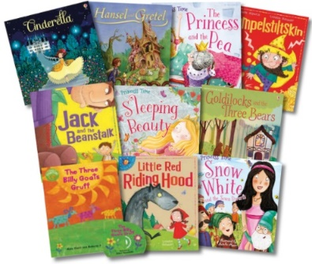
Please email us 1 or 2 photos of what you have been up to with your children over the easter holidays. This is for our new display. Please also fill in the Easter Egg-cellence form as we like to display what you say about your children in our classroom.
Kind Regards,
Mrs Divall, Mrs Zaayman and Mrs Degun

