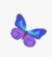
What are you most proud of your child for this year?

What was your child’s favourite learning this year?
Do you have any comments about your child’s year in Reception that you would like us to know about?

Please return your End of Year Proud Clouds as soon as possible.

