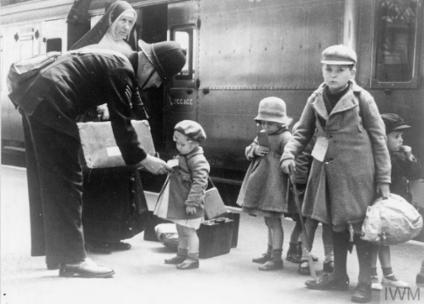

**Science**

* For Science this term we will be learning about the heart and blood. We will be learning about the composition of blood and how it travels through our body as well as how the heart beats to pump blood around the body
* We will look at how a healthy / unhealthy lifestyle can impact our heart health

**English**

* This term in English we will be writing narratives. We will be using a variety of stimuli for our writing and will be looking at how we can engage our reader using description.
* In Reading, we will be looking at poem “The Lady of Shalott” and we will be using this poem to complete a range of activities. We will be answering our VIPERS questions based on this text

**Maths**

When learning about algebra we will be:

* Forming equations
* Solving simple equations
* Finding pairs of values

When learning about decimals we will be:

* Decimals up to 3dp
* Multiple/ divide by 10, 100, 1000
* Division to solve problems

When learning about fractions, decimals and percentages we will be:

* Equivalent fractions, decimals and percentages
* Percentage of an amount
* Finding a missing percentage

**History**

In History this term, we will be continuing our work on Britain during World War Two. We will be looking into significant events such as the battle of Britain and significant individuals such as Anne Frank. We will also be looking at post war Britain and how we remember these important events today.

**Britain at War (2)**