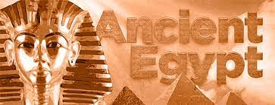

**Geography**

* Egypt on a map, using an atlas or Google Earth. Locate the Nile river, the Mediterranean Sea and countries that surround Egypt. Draw a simple sketch map and include a key to show some of the geographical features of the country.
* Use your knowledge and research skills to create an information text or poster about the Nile in ancient Egypt. Include information about why the ancient Egyptians lived near the river, and why the river was so important to ancient Egyptian society. Compare how people used the river then and today.
* The fertile northern area of Egypt is called the Nile Delta. Use a range of sources to find out how deltas form and how they benefit the area. Record your findings and draw a labelled sketch of the Nile Delta.

**History**

* Draw a labelled hierarchy pyramid to show the ancient Egyptian hierarchical system, which included different social classes.
* Use information books and the internet to find out about the following ancient Egyptian royals: Ramses II, Nefertiti, Akhenaton and Tutankhamun. Record your findings in a table, including a picture and up to four facts about each of the rulers.
* Ancient Egyptian writing is called hieroglyphics. Use your knowledge, the internet or information books to answer the questions about this ancient Egyptian writing system.

*What are hieroglyphics and how are they different from our writing system?*

*What does hieroglyph mean?*

*What is a cartouche?*

*What is a stele?*

*What is the Rosetta Stone and why is it important?*

* Practise writing in hieroglyphics. Challenge a friend or family member to work out what you have written.