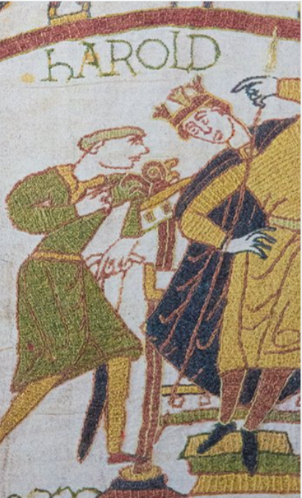

**PE**

* This term, PE will be changing to a **Tuesday morning.** Please can the children come to school in their PE kits on a Tuesday. The children will also have **one more swimming session, on Thursday 6th June.** The children must come into school in their PE kits that day with all of their usual swimming equipment.

1066

**Maths**

Throughout this term, we will be:

* Learning about statistics, specifically line graphs, pictograms and charts.
* Moving onto to properties of shape. This will include exploring angles, 2-D shapes, quadrilaterals, triangles, symmetry and the difference between horizontal/vertical lines.
* Our final topic will be position and direction, looking at drawing and moving on a grid.
* Importantly, the children will have their multiplication check this term. Please ensure that they are practising their times tables at home at least twice a week via Times Table Rockstars (or good old-fashioned pen and paper).

**Literacy**

* This term, we are continuing to read the novel Alice in Wonderland by Lewis Carroll. During our reading lessons, we will be continuing to develop our skills in defining vocabulary, inference, making predictions, retrieval and summarising/sequencing events.
* In Writing, we will begin the term by writing a Newspaper report about the scientist Hertha Ayrton to celebrate our Science week. Then, we will be writing a narrative based on a short film called ‘The Present’. This will be the final opportunity for the children to showcase their creative writing skills.

**Topic**

* In Science, our topic will be Animals including Humans- the environment. The children will be looking at what environmental impacts climate change has, and what we can do to help restore our planet.
* Due to our topic being 1066, in History/Geography we will be looking into the Battle of Hastings in detail, including the events in the lead up to the battle. We also have our trip to Mountfitchet Castle on Friday 17th June. Please ensure that you have handed in the permission slips the week before we go!
* In Art/DT, we will be making our own Bayeux Tapestry, and we will be designing and making clay figures. Two new skills for the children to explore!
* We will also continue to have weekly Music, Computing, PSHE and French lessons, continuing on with the learning we began in Summer 1.