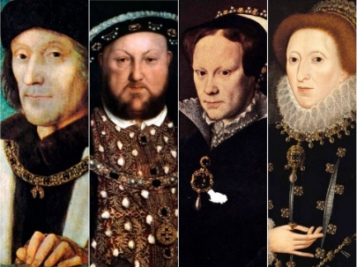

**Maths**

This term in Maths we will be looking at a range of concepts:

* Multiplying and dividing using written methods
* Calculating fractions of a quantity and amount
* Multiplying fractions by integers
* Identifying decimals up to 2 decimal places
* Finding equivalent fractions and decimals
* Ordering and compare decimals
* Rounding decimals

Year 5 - Spring 1 Off with her head

**Important dates**

* Class assembly – Thursday 9th February
* Trip to Tower of London – Wednesday 25th January
* Shared learning – Monday 20th March

**Art**

* In Art this term we will be looking at the work from a range of artists. We will be using a range of materials to improve our drawing and observational techniques

**P.E**

* This term P.E will be on a **WEDNESDAY**

**Science**

* In Science we will be looking at how materials change and will be investigating a range of reversible and irreversible changes

**English**

* This term for English we will be looking at the features of biographies and writing our own on key individuals in the Tudor era.
* We will also be revising how to use persuasive language in our writing and will be using this within persuasive letters.
* For reading, we will be looking at the book Treason which is set in the Tudor period.

**Topic – Tudors**

* In History we will be looking at the Tudor era and ordering key events on a timeline.
* We will be looking at maps in Geography and identifying the differences between Tudor London and modern London. We will also be using maps to locate key landmarks in Tudor London.
* When looking at Henry VIII, we will be looking at his marriages and where he lived in the UK.
* We will also be looking at crime and punishment in Tudor times.