**Geography**

* Research significant Victorian battles such as the famous Battle of Oltenita in 1853, the Battle of Isandlwana in 1879, or Rorke’s Drift in 1879. Produce maps or plans to explain battle strategies.
* Find out about Victorian railways using Bradshaw’s Guide (bradshawsguide.org). Read the town descriptions in the original guides and find out how much these places have changed using modern information sources.
* Research the Victorian Empire and create annotated maps showing the extent of British rule. How does this link to today’s Commonwealth? Perhaps choose a single area to focus on, such as Britain in India.

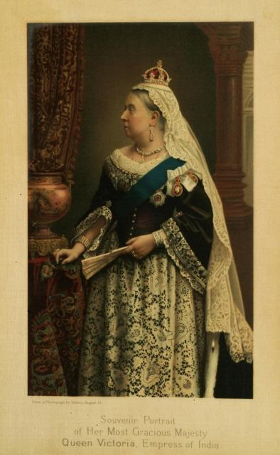

**Maths**

* Practise writing numbers up to 1 million.
* Roll a die and use the numbers as digits in a 6 digit number – try to make the largest number.
* Practise using formal written methods of addition, subtraction, multiplication and division.
* ***Continue to use TimesTable Rockstars***

**Art and Design**

* Make some simple Victorian recipes, such as Apple Charlotte, Banbury cakes and custard patties. Create a recipe book using photos of your creations.

**Literacy**

* Read some abridged Charles Dickens, such as Oliver Twist and Other Great Dickens Stories by Marcia Williams, or watch film versions of his stories and create your own ‘Junior Guide to the Greatest Novelist of the Victorian Period’. Include with reviews of films and books to appeal to other children and give them a thumbs-up or star rating.
* Write a newspaper article about the London matchgirls’ strike of 1888. Find out about the gruesome side effects of phosphorous on the health of the girls in the factory. Create campaign posters to help advertise the strike
* ***Continue to practise spellings and read daily.***

Revolution

**History**

* Find out about health and medicine in Victorian times, including ghastly and deadly diseases like typhoid, smallpox, influenza and cholera. It was pretty grim!
* Find out about significant women of the Victorian era, such as Mary Seacole, Florence Nightingale, Elizabeth Garrett Anderson (the first English woman to qualify as a doctor), Charlotte Brontë, George Eliot (whose real name was Mary Ann Evans) and Mrs Beeton.
* Find out about life as a child worker in factories and coal mines or as chimney sweeps and scullery maids. Write a ‘Day in the Life of a… ’ diary entry and add illustrations.