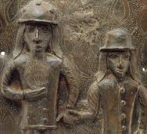

**SATs**

In the lead up to SATs, please visit our class name ‘6B’ on the website for supporting documents regarding reading comprehension, SPaG and maths and complete as much homework sent home as possible.

**History**

* Choose and research a significant figure from black history. Create a fact file about your chosen figure. Here are some ideas on who you may like to research:
* Mary Seacole
* Thomas Clarkson
* Claudia Jones
* Olaudah Equiano

**Science**

* Make a fact file about different fossil types
* Explain how animals such as polar bears, monkeys and sharks have evolved to suit their environment. Design a new fantastical creature that has evolved to suit its unique environment.
* Find out more about other famous scientists who had an interest in evolution and inheritance, such as Alfred Wallace or Mary Anning
* Visit the Great Plant Hunt website and be a plant detective – just like Charles Darwin!

**English**

* Write a non- chronological report about Africa. You might like to include details about its area, population, geography, land use, languages spoken and the names and locations of particular countries.
* Write a newspaper article based around real events that took place during the transatlantic slave trade.

**Maafa**