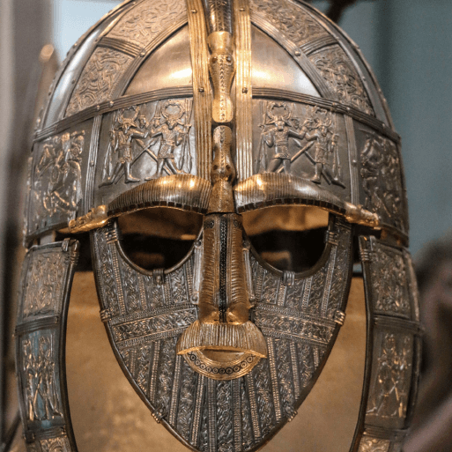

**PE**

* This term, PE will continue be on a Tuesday morning. Please ensure that children still come into school wearing their PE kit.

**Literacy**

* This term, we are reading the novel Rumblestar by Abi Elphinstone. We will be continuing to develop our skills in defining vocabulary, inference, making predictions, retrieval and summarising/sequencing events.
* In English, we will be exploring two new pieces of writing skills. We will begin by writing a Biography on King Athelstan, and then the children will be writing their very own Playscript. This will be based on a Anglo-Saxon play, and the children will write the next scene of the play.

**Maths**

Throughout this term, we will be:

* Our first unit will be focused on area, looking at counting squares and comparing areas of different shapes.
* Then, we will be moving on to multiplication and division. The children will be learning the 3, 6 and 9 times table.
* Next, the children will be learning their 7, 11 and 12 times tables, as well as division facts.
* To conclude this unit, the children will be learning how to divide by 1 and 0, divide a number by 1 and itself and multiplying three numbers.
* Also, we will be continuing to practice our specific times tables for the weekly test (still on Tuesday mornings).

**Topic**

* In History, we will be travelling through the Anglo-Saxon and Viking period, looking at how invasion affected life both on mainland Europe and in Great Britain.
* In DT, the children will be learning all about food, including how to keep food fresh, making their own packaging and creating their own healthy snack.
* In Science, we will be learning about Sound, including naming parts of the ear, explaining how sounds travels and comparing high and low pitches.
* For our RE lessons, we are going to continue learning about Judaism, before moving on to look at religious festivals such as Diwali and Christmas.
* We will also be continuing with our weekly French, Computing, Music and PSHE lessons. In French, we will be looking at colours and numbers up to 20. In Computing, the children will be adding to their research and coding skills.

Invasion