In Reception this Half Term our topic is called Starry Night. Here are some examples of activities that we would like your child to take part in. You should aim to complete and send in evidence of at least three of these activities. We will display them in our classrooms. You can bring them in as soon as they have completed. The final date for completion is 9th December 2022.
Talk about bedtime routines and the importance of a good night’s sleep. Make a list of bedtime activities that you have.
Do you celebrate any events this half term? E.g. Diwali, birthday, Christmas, Hanukkah? Can you send in any photos, paintings or drawings of your day?

Check out cbeebies Space for games, radio, clips and lots of learning.

Make a room dark, shine a torch onto a wall and make shadows by putting objects in front of the torch. You could play a guess the object game.
Use the internet (with an adult) to find out all about nocturnal animals, write a simple fact(s)
Lullabies are soothing. Find some lullabies to listen to together and choose your favourite
Starry Night
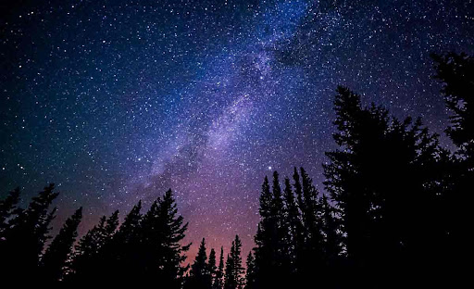
Go outside on a clear night and look at the sky, draw a picture of what you can see.

Use glow sticks to practise writing your name and simple words and letters in the air.
Go on a short walk during the day and then go on the same walk after dark. Take a torch! What did you see and hear on your day time walk and your night time walk?

Visit the Library and have a look for books about the stars, nighttime, space, planets and books. What can you find out?

