jump
dance
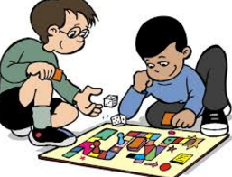play
shout

Use a past tense word in your own sentence.
Example: Play > played
I played with my friends.

________________________________________________________________________________

jump
dance
play
shout
splash
lift
hiss

Use a past tense word in your own sentence.
Example: Play > played
I played with my friends.

________________________________________________________________________________
________________________________________________________________________________
________________________________________________________________________________
________________________________________________________________________________

Wednesday 19th January 2022
L.O: I can use the ‘ed’ suffix.

Use a past tense word in your own sentence.
Example: Play > played
I played with my friends.

________________________________________________________________________________
________________________________________________________________________________
________________________________________________________________________________
________________________________________________________________________________

jump
dance
play
shout
splash
lift
hiss

Use a past tense word in your own sentence.
and but so because

________________________________________________________________________________
________________________________________________________________________________
________________________________________________________________________________
________________________________________________________________________________

Wednesday 19th January 2022
L.O: I can use the ‘ed’ suffix.

Use a past tense word in your own sentence.
and but so because

________________________________________________________________________________
________________________________________________________________________________
________________________________________________________________________________
________________________________________________________________________________

